

**Web-Based Computer Hardware Purchasing and Troubleshooting Assistant Management**

**System**

G.P saNKALPA  
Bit Registration No: - R180527  
Index No: - 1805274

Name of the Supervisor:   
M.P. Sarath Wijesinghe

 **April 2022**



**This dissertation is submitted in partial fulfillment of the requirement of the Degree of Bachelor of Information Technology of the   
University of Colombo School of Computing.**

# Declaration

“I certify that this dissertation does not incorporate, without acknowledgement, any material previously submitted for a degree or diploma in any university, and to the best of my knowledge and belief, it does not contain any material previously published or written by another person or myself except where due reference is made in the text. I also hereby give consent for my dissertation, if accepted, to be made available for photocopying and interlibrary loans, and for the title and abstract to be made available to outside organizations.



Signature of Candidate: . . . . . . . . . . . . . . . . . . . . . . . Date: 29/01/2021

Name of Candidate: G.P Sankalpa

Countersigned by:

Signature of Supervisor(s)/Advisor(s): . . . . . . . . . . . . . . . . . . . . . Date: 29/01/2021

Name(s) of Supervisor(s)/Advisor(s): Mr. M.P.S.Wijesinghe

# Abstract

The computer sales and servicing industry sells and services a wide range of computers, including desktops, laptops, notebooks, palmtops, and software, as well as peripherals such as printers, scanners, and keyboards. These products are typically purchased from domestic and foreign producers and distributors before being distributed to end-users such as households and companies.

Under the present system of U-Star Digital, customers used to come into the store and communicate their demands to the technician who built their computer. Customers arrived at the store, gave over the defective item or computer to the technicians, and then waited in their restroom until the task was finished. They presently use a phone-based and WhatsApp-based order system to take online orders. There are no other options than bank transfers, and the customer must confirm the order with formal transaction documents. Due to a lack of adequate delivery information, customers are not given accurate delivery information.

The main purpose of the research is to create and develop an online system for managing computer hardware and services that will help the company and its employees become more popular with their customers and market their business via the internet.

For modeling, the system uses a client-server architecture and a non-object-oriented iterative software development process called Rational Unified Process. The system is designed using the Unified Modeling Language. For front-end development, PHP is utilized as the server-side programming language, along with HTML, JavaScript, and CSS. As an integrated development environment, the Microsoft Visual Studio Code is employed. The Apache web server is utilized and MySQL is used to manage the database. It may be used with a web browser on any GUI-based OS platform as this is a web-based system. This system has offered to meet the needs of the client. It will be quite beneficial in archiving their commercial objectives.

# Acknowledgements

First and foremost, I would like to convey my heartfelt gratitude to my supervisor, Mr. M.P Sarath Wijeshinghe, Assistant Director – IT, Sri Lanka Export Development Board, for his unwavering support, and helpful assistance, and constant supervision despite his hectic schedule.

Mr.R.S.Kannangara, the owner of U-Star Digital, was also extremely helpful in gathering requirements and conducting user acceptance tests. Also, I wish to express my gratitude to other members of the U-Star Digital team for volunteering their time to help with domain-related information.

I'd like to thank the Project Coordinator and Academic Coordinator, University of Colombo School of Computing, and the Project Examination Board of Bachelor of Information Technology for allowing me to put my degree program's expertise to use. Also, my heartfelt gratitude goes to all of my lecturers who educated me throughout my BIT degree program.

In addition, I owe gratitude to my friends who encouraged and supported me by providing input on the system's and website's user interfaces. Last but not least, I want to express my gratitude to my parents, who have provided all of the required supplies for the project and have provided me with a great deal of motivation and mental support in order to make this project a success.

Table Contents

Declaration ii

Abstract iii

Acknowledgements iv

List of Figures ix

List of Tables xi

List of Acronyms xii

Chapter 1 – Introduction 13

1.1 Chapter Introduction 13

1.2 Introduction to U-Star Digital 13

1.3 Motivation of the Project 13

1.4 Objectives of the Project 14

1.5 Scope of the Project 14

1.5.1 Shopping Cart Module 14

1.5.2 Payment Module 14

1.5.3 Inventory Management Module 15

1.5.4 Delivery Management Module 15

1.5.5 Troubleshooting Assistant Module 15

1.5.6 Invoice Generating Module 15

1.5.7 User Management Module 15

1.5.8 Report Management Module 15

1.6 Structure of Dissertation 15

Chapter 2 – Analysis 17

2.1 Chapter Introduction 17

2.2 Fact Finding Techniques 17

2.2.1 Interviews 17

2.2.2 Observation 18

2.2.3 Existing Documents Analyzing 18

2.3 Existing System 18

2.4 Existing System Data Flow Diagram 18

2.5 Requirements Analysis 20

2.5.1 Functional Requirements 20

2.5.1 Non-Functional Requirements 21

2.6 Similar Systems and Literature Reviews 22

2.6.1 Microcenter 22

2.6.2 Newegg 23

2.6.3 Comparison of the Proposed System to a Comparable System 23

2.7 Model of the Proposed System's Process 24

2.7.1 Scrum 24

2.7.2 Extreme Programming (XP) 24

2.7.3 Rational Unified Process (RUP) 24

Chapter 3 – Design 26

3.1 Chapter Introduction 26

3.2 Alternate Solution 26

3.2.1 Stand-alone System 26

3.2.2 Collection of Software 26

3.2.3 Reason to Choose the Web-Based System 26

3.3 The Architectural Design of the System 27

3.4 Use Case Diagram for the Proposed System 27

3.5 Use Case Narratives for the Proposed System 29

3.5.1 Use Case Narratives for Login Module 29

3.5.2 Use Case Narratives for Insert Inventory Item 30

3.6 ER Diagram for the Proposed System 31

3.7 Releational Shecma for System 32

3.8 Activity Diagrams for the Proposed System 33

3.8.1 Activity Diagram for Login 33

3.8.2 Activity Diagram for Add Item 33

3.9 – UI Designs for the Proposed System 34

3.9.1 – Customer Login Form UI Design 34

3.9.2 – Customer Register Form UI Design 34

3.9.3 – Customer Checkout UI Design 35

3.9.3 – Add Inventory Item Form 36

Chapter 4 – Implementation 37

4.1 – Chapter Introduction 37

4.2 – Implementation Environment 37

4.2.1 – Software Environment 37

4.2.2 – Hardware Environment 38

4.2.3 – Other Softwares and Development Tools 38

4.3 – Justification for the choice of the implementation platform 38

4.3.1 System File Structure 40

4.4 – High Level Module Structure 40

4.5 – Major Code Segments 41

4.5.1 – Customer Checkout Code Segments 44

4.6 – Reused Existing Codes 45

Chapter 5 – Evaluation 48

5.1 – Introduction 48

5.2 - Description of testing approach 48

5.3 - Test plan 48

5.3.1 - Verification and Validation 49

5.3.2 - Testing Process 49

5.5 - User Acceptance Testing 52

5.6 - User Evaluation 52

Chapter 6 – Conclusion 56

6.1- Introduction 56

6.2 - Critical evaluation of the project 56

6.3 - Lesson learned 56

6.4 - Future work 57

References 58

Appendix A – System Manual 59

Appendix B – Design Documentation 62

Appendix C – User Manual 68

Appendix D – Management Reports 77

Appendix E – Test Results 80

Appendix F – Client Certificate 87

Glossary 88

Index 89

# List of Figures

Figure 2. 1: Data Flow Diagram for the Existing System. 19

Figure 2. 2: Interface Design of Microcenter Similar System 22

Figure 2. 3: Interface Design of NewEgg Similar System 23

Figure 3. 1 Proposed System Use Case Diagram 28

Figure 3. 2: ER Diagram for Proposed System 31

Figure 3. 3: Activity Diagram for Login 33

Figure 3. 4: Activity Diagram for Add Item 33

Figure 3. 5: Login Form UI Design 34

Figure 3. 6: Register Form UI Design 34

Figure 3. 7: Order Checkout form 35

Figure 3. 8: Add Items form 36

Figure 4. 1: Hardware Environment 38

Figure 4. 2: File Structure 40

Figure 5. 1: User Feedback Form 53

Figure 5. 2: User Acceptance Test Evaluation Sample 54

Figure 5. 3: Summary of User Feedback Evaluation 55

Figure A. 1: XAMMP Server Download Page 60

Figure A. 2: Create Database 60

Figure B. 1: Use Case Diagram for Customer Registration 62

Figure B. 2: Use Case Diagram for Order Checkout 64

Figure B. 3: Activity Diagram for Customer Login 66

Figure B. 4: Activity Diagram for Order Checkout 67

Figure C. 1: Home Page 68

Figure C. 2: Category Page 69

Figure C. 3: List Item Page 69

Figure C. 4: Item Page 70

Figure C. 5: Cart Page 70

Figure C. 6: Checkout Page 71

Figure C. 7: Invoice Page 72

Figure C. 8: Add Category Form 73

Figure C. 9: Add Brand Form 73

Figure C. 10: Add Models Form 73

Figure C. 11: Add Items Form 74

Figure C. 12: Add Employee 75

Figure C. 13: Add user modules 76

Figure D. 1: Report of Orders 77

Figure D. 2: Report of Items 77

Figure D. 3: Report of Order Deliveries 78

Figure D. 4: Report of Stock 78

Figure D. 5: Report of Product Categories 79

Figure E. 1: User Acceptance Test Result One 84

Figure E. 2: User Acceptance Test Result Two 85

Figure E. 3: User Acceptance Test Result Three 85

Figure E. 4: User Acceptance Test Result four 86

# List of Tables

Table 2. 1: Stakeholders Interview Schedule 18

Table 2. 2: Comparison between Proposed System and Similar Systems 23

Table 2. 3: Comparison between Different Process Models 25

Table 3. 1: Use Case Narrative for Login Module 29

Table 3. 2: Use Case Narrative for Inventory Item 30

Table 5. 1: Test Case for Customer Registration 51

Table 5. 2: Test Results for Customer login 51

Table 5. 3: Test Result for Checkout Process 52

Table A. 1: Hardware Requirements 59

Table A. 2: Software Requirements 59

Table B. 1: Use Case Narrative for Customer Registration 64

Table B. 2: Use Case Narrative for Order Checkout 65

Table E. 1: Test Result for Customer Registration 81

Table E. 2: Test Result for Customer Login 82

Table E. 3: Test Result for Checkout Process 84

# List of Acronyms

**AJAX** – Asynchronous JavaScript and XML

**BIT** – Bachelor of Information Technology

**CC** – Creative Cloud

**CD** – Compact Disc

**CSS** – Cascading Style Sheets

**ER** – Entity Relationship

**FIFO** – Frist In Frist Out

**HTML** – Hypertext Markup Language

**ICT** – Information Communication Technology

**IDE** – Integrated Development Environment

**PEB** – Project Evaluation Board

**PHP** – PHP Hypertext Preprocessor

**RUP** – Rational Unified Process

**SQL** – Structured Query Language

**UAT** – User Acceptance Testing

**UCSC** – University of Colombo School of Computing

**UI** – User Interface

**UML** – Unified Modeling Language

**URL** – Uniform Resource Locator

**XAMMP** – Apache + Maria DB + PHP + Perl

**XP** – Extreme Programming

# Chapter 1 – Introduction

## 1.1 Chapter Introduction

This chapter provides an overview of U-Star Digital and the client's planned system. This will also cover the background and rationale for starting the project, as well as the project scope and objectives, and also the dissertation format.

## 1.2 Introduction to U-Star Digital

Many types of computers, including desktops, laptops, notebooks, palmtops, and software, as well as peripherals like printers, scanners, and keyboards, are sold and serviced in the computer sales and servicing industry. Before being supplied to end-users, such as households and businesses, these products are frequently purchased from domestic and international producers and distributors.

U-Star Digital is a renowned information and communication technology (ICT) company that has been in existence since 2010. They provide an unrivaled program and experience in ICT equipment repair, servicing, maintenance, and cleaning. They are depending on its technically advanced next-generation infrastructure to deliver best in class customer-aware and lifestyle-enhancing products and services that anticipate customers' needs.

## 1.3 Motivation of the Project

Customers used to come into the store and convey their needs to the technician who built their computer under the old system. Customers arrived at the shop, handed over the defective item or computer to the hardware professionals, and then waited in their restroom until the job was completed. To take online orders, they currently utilize a phone-based and WhatsApp-based order system. There are no other options than bank transfers, and the customer must send legal transaction paperwork to confirm the order. Customers are not given accurate delivery information due to a lack of appropriate delivery information.

Customers are on the go, busy, and mobile. They want frictionless and seamless services. By gaining a solid understanding of the needs of customers they are provided with a convenient product browsing experience, a simple payment system, and a delivery tracking system that allows customers to track their order as it arrives at their home.

An outstanding solution for U-Star Digital to continue their greatness in the computer sales and maintenance sector in this digital age can be added. By the same token, while pursuing a Bachelor's degree in Information Technology, this effort would substantially assist me in improving my project management, system analysis, design, and development abilities.

## 1.4 Objectives of the Project

The study's overall goal is to build and develop an online system for managing computer hardware and services that will assist the company and its employees in becoming more popular with their consumers and marketing their business through the internet.

The study's particular objectives are as follows:

* Providing a feature-rich product browsing method, as well as a simple payment and delivery mechanism, to fulfill the customer's order.
* Inventory management, which makes it easy to manipulate items for the store and receive automated alerts when stock levels are low.
* Generate a variety of reports and graphics, including sales and stock data, to assist management in making decisions.
* Using an automated question-based module to implement Online Troubleshooting, and suggest the appropriate solution for resolving the problem.

## 1.5 Scope of the Project

Web-Based Computer Hardware Purchasing and Troubleshooting Assistant management system has a broad reach that includes the following points of view.

### 1.5.1 Shopping Cart Module

This module allows users to find the entire store for items and create customer orders using a shopping cart.

### 1.5.2 Payment Module

This module provides up-to-date information on all payments made by customers, as well as advanced payment filtering options and having bank transfers, and cash on delivery options.

### 1.5.3 Inventory Management Module

Has the ability to handle the complete inventory. Individual items and corresponding categories, brands, and models can be added, deleted, and updated.

### 1.5.4 Delivery Management Module

This module contains all of the customer-created delivery records in the system. It displays the order tracking number as well as information about the courier company.

### 1.5.5 Troubleshooting Assistant Module

With the help of this virtual assistant, consumers may troubleshoot their hardware failures with the most acurate videos and the description.

### 1.5.6 Invoice Generating Module

In the system, this module generates a variety of invoices. It's compatible with the payment, computer hardware assistant, and troubleshooting modules.

### 1.5.7 User Management Module

This module helps to manage all of the users of the system. It aids in the selection of the right individual for the right position.

### 1.5.8 Report Management Module

This module will make it possible to generate, preview, and print a variety of reports in order to continue with the success of the business.

## 1.6 Structure of Dissertation

The introduction is the first of six chapters in the dissertation. The contents of each chapter are listed below in brief.

Chapter 1 – Introduction

The project's goals and scope are explained in this chapter. It also explains the present system's flaws and what motivates the creation of this system.

Chapter 2 – AnalysisThis chapter covers requirement collection strategies for both functional and non-functional requirements for a new system, as well as analysis approaches for understanding the existing system.

Chapter 3 – Design

The system's design, including database and user interface design, is covered in this chapter. To make the system's structure easier to understand, this chapter also contains top-level and module-level use cases.

Chapter 4 – Implementation

This chapter covers implementation technologies, hardware and software requirements, and the structure of key code modules.

Chapter 5 – Evaluation

This chapter explains how the system was tested using test cases and what the outcomes were. It describes the test cases and situations that were employed.

Chapter 6 – Conclusion

This chapter summarizes the lessons learned and suggests ways to enhance the system in the future.

Finally, a Glossary of Terms and a General Index are included.

# Chapter 2 – Analysis

## 2.1 Chapter Introduction

The process of identifying the underlying problem and comprehending the problem domain from a jumble of facts and figures is known as analysis. The purpose of the analysis is to provide a complete, consistent, and unambiguous image of the system. Also, what should the system supply to meet all user requirements. Requirements Engineering is another name for this procedure. The system can be designed with the help of analysis.

## 2.2 Fact Finding Techniques

Fact-gathering procedures are information-gathering strategies used in system analysis to properly define and comprehend system requirements. The following strategies were primarily employed:

1. Interviews
2. Observation
3. Existing Documents Analyzing

### 2.2.1 Interviews

The initial technique utilized to collect and establish system requirements, as well as clarify and confirm those needs, was an interview. In order to effectively address and weigh the inputs of each interviewee, the interviewer must first comprehend the perspective of each interviewee.

The following is the interview schedule that was used.

|  |  |  |  |
| --- | --- | --- | --- |
| **Date** | **Interviewee** | **Position** | **Interview Duration** |
| 23/10/2021 | Mr. Samudu Kannangara | Owner | 40 minutes |
| 23/10/2021 | Mr. Upali Kannangara | Stock Keeper | 30 minutes |
| 23/10/2021 | Mr. Thamara Kannangara | Technician | 40 minutes |
| 25/10/2021 | Mr. Susith Sewikrama | Delivery Manager | 20 minutes |
| 25/10/2021 | Mr. Chamara Perera | Technician | 30 minutes |
| 27/10/2021 | Miss. Kalpani Dinusha | Customer | 20 minutes |

Table 2. : Stakeholders Interview Schedule

### 2.2.2 Observation

Observation is a fact-finding technique in which system analysts observe how individuals perform tasks and activities during site visits. This is an excellent approach to learn what end users go through in their day-to-day processes, and it gives you a lot of insight into the business process.

### 2.2.3 Existing Documents Analyzing

Analyzing existing papers is a key strategy for acquiring requirements. When building a user-friendly system, evaluating the papers and reports of an existing system can help. Solid information and facts are usually collected by studying existing papers, which helps to corroborate and validate the requirements gathered through other methods.

## 2.3 Existing System

From the beginning, U-Star Digital has used a semi-paper-based manual approach. During the system analysis phase, it was discovered that the current system can only perform a limited number of functions.

Customers used to come into the store and convey their needs to the technician who built their computer under the old system. Customers arrived at the shop, handed over the defective item or computer to the hardware professionals, and then waited in their restroom until the job was completed. To take online orders, they currently utilize a phone-based and WhatsApp-based order system. There are no other options than bank transfers, and the customer must send legal transaction paperwork to confirm the order. Customers are not given accurate delivery information due to a lack of appropriate delivery information.

## 2.4 Existing System Data Flow Diagram

There were numerous downsides to the paper-based technique.

* It was discovered that data was repeating.
* Data that is unidentifiable owing to illegible handwriting.
* Data was lost because of misplacing the recording materials.
* It takes a long time.
* Manual computations are required.
* Data security is lacking.
* More manpower is required.

The following data flow diagram illustrated by existing system (Figure 2.1).

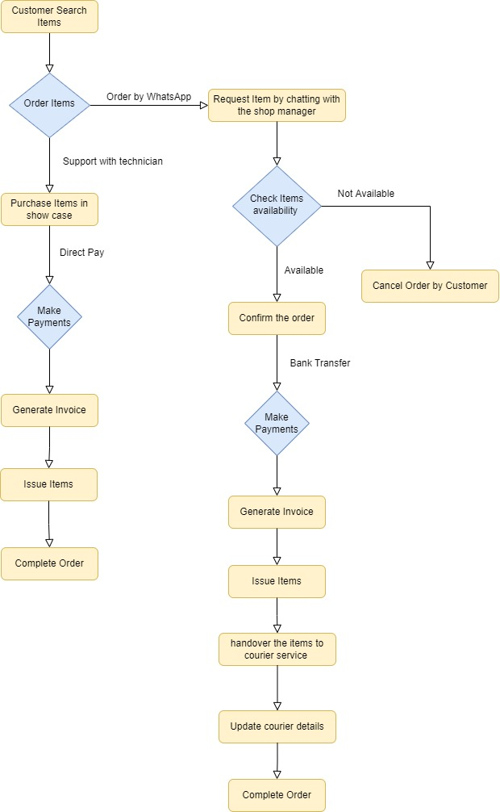

*Figure 2. 1: Data Flow Diagram for the Existing System.*

## 2.5 Requirements Analysis

### 2.5.1 Functional Requirements

Calculations, data insertion, manipulation, and processing, as well as data presentation, are all defined by functional requirements. The system's required features are listed below.

* **Shopping Cart**
  + Customer search and select items to add to the cart.
  + Customers can make the order in the selected items in the cart.
  + Calculates selected items' totals and discounts.
  + Orders are recorded in the Customer Dashboard Orders section and Shop Managers Orders section.
  + Able to update order status.
  + Notify the shop manager of a new order.
* **Payment**
  + Customers can select the payment method.
  + Carry the order totals to the payment method.
  + Proceed to checkout with total payment.
* **Inventory Management** 
  + Insert, update and delete the Items, Brands, Models, and Item Specifications.
  + Notify with low stock and out-of-stock Items.
  + Able to create a low stock threshold.
  + Able to create discounts with a selected number of date periods.
* **Delivery Management** 
  + Able to create courier companies.
  + Customers can notify with courier company details and order tracking numbers when the order is dispatched.
  + Customers can view their order details by giving the courier company a tracking URL using the tracking number.
  + Customers were able to update the courier process when receiving the item.
* **Troubleshooting Assistant**
  + Customers select the type of defect.
  + Load appropriate answer form already configerd in the database.
  + Show the answers related to the customer selected answer.
* **Invoice Generation** 
  + Calculate order totals and courier payment and generate an invoice for the customer.
  + Invoices can filter with the selected date range.
  + Invoices can export and have the ability to print.
* **User Management**
  + Able to manage all of the users of the system.
  + Aids to create user roles and permission.
* **Report Management**
  + This module will make it possible to generate, preview, and print a variety of reports.
  + Able to export and filter the reports within the selected time frame.

### 2.5.1 Non-Functional Requirements

Non-functional requirements had to be met in order for a system to be valuable and successful.

* **Usability**

The system is directly connected to all of the shop's consumers. Users of the system can access necessary reports over the internet. Giving clients better service means making data easier to access and sending notifications about existing purchases.

* **Maintainability**  
  It's simple to correct a bug, add new features, make changes to support new operating systems, and make the software easier to maintain for others. It also improves the contentment of members.
* **Performance**

The system should be quick and finish the task in the shortest time possible. Data should be retrieved as soon as feasible, and the response time should be minimal.

* **Security**

Considering client personal information such as email addresses, phone numbers, and physical addresses is saved in the system, security is a top priority for the system to protect users' sensitive data.

* **Reliability and accuracy**

The system's major features include the generation of progress reports and workout programs. As a result, the system's accuracy and dependability are critical.

## 2.6 Similar Systems and Literature Reviews

It was required to examine the existing system before designing the web-based Computer Hardware Purchasing and Troubleshooting Assistant management system. Because the current system is semi-paper-based, a literature review and related system analysis were also decided. The systems listed below were evaluated in order to have a thorough understanding of the situation.

### Graphical user interface Description automatically generated2.6.1 Microcenter

Figure 2. : Interface Design of Microcenter Similar System

Micro Center offers more computers, electronics, networking, and communication devices (more than 30,000 items in stock) than any other company. Micro Center is deeply passionate about providing information technology products and technology support services. We have offered in-store pickup of online orders since 2010.[1]

### 2.6.2 Newegg

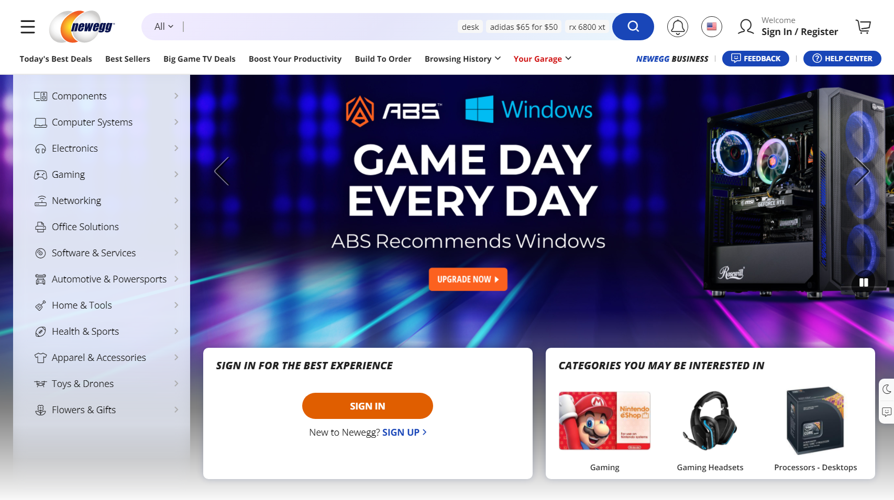

Figure 2. : Interface Design of NewEgg Similar System

“Today, millions of customers turn to Newegg to shop for the latest PC components, consumer electronics, smart home and gaming products. Newegg is consistently ranked as one of the best online shopping destinations, and the company regularly earns industry-leading customer service ratings.” [2]

### 2.6.3 Comparison of the Proposed System to a Comparable System

The results of the comparison as below (table 2.2)

|  |  |  |  |
| --- | --- | --- | --- |
| **Functionality** | **Proposed System** | **Microcenter** | **NewEgg** |
| Shopping Cart | Yes | Yes | Yes |
| Payment Management | Yes | Yes | Yes |
| Inventory Management | Yes | Yes | Yes |
| Delivery Management | Yes | Yes | Yes |
| Troubleshooting Assistant | Yes | No | No |
| Computer Hardware Assistant | No | Yes | No |
| Mobile App | No | No | Yes |

Table 2. : Comparison between Proposed System and Similar Systems

## 2.7 Model of the Proposed System's Process

The Software Development Process, also known as the Software Development Lifecycle, is the division of software development activity into phases in order to better design, project management, and product management.

Scrum, Extreme Programming (XP), RUP, and other process models exist for developing software systems.

### 2.7.1 Scrum

“The Scrum process organizes development into a sequence of sprints, each of which results in a potentially usable product with an added increment of function. The tasks for each sprint are set, in consultation with a stakeholder representative, during a sprint planning meeting and cannot be added to during the sprint. Each task is typically expressed as a user story. Each sprint is time boxed: the end date of the sprint does not change. Tasks that cannot be accomplished in time are returned by the team to the backlog for future consideration.” [3]

### 2.7.2 Extreme Programming (XP)

“Extreme Programming (XP) is an agile software development framework that aims to produce higher quality software, and higher quality of life for the development team. XP is the most specific of the agile frameworks regarding appropriate engineering practices for software development.” [4]

### 2.7.3 Rational Unified Process (RUP)

“Stands for "Rational Unified Process." RUP is a software development process from Rational, a division of IBM. It divides the development process into four distinct phases that each involve business modelling, analysis and design, implementation, testing, and deployment. The four phases are:

1. **Inception -** The idea for the project is stated. The development team determines

if the project is worth pursuing and what resources will be needed.

1. **Elaboration -** The project's architecture and required resources are further

evaluated. Developers consider possible applications of the software and costs

associated with the development.

1. **Construction -** The project is developed and completed. The software is

designed, written, and tested.

1. **Transition -** The software is released to the public. Final adjustments or updates

are made based on feedback from end users.

The RUP development methodology provides a structured way for companies to envision create software programs. Since it provides a specific plan for each step of the development process, it helps prevent resources from being wasted and reduces unexpected development costs” [5]

Based on the considerations outlined in Table 2.3, the Rational Unified Process (RUP) was chosen as the best process model for the proposed system over other approaches.

|  |  |  |
| --- | --- | --- |
| **RUP** | **Scrum** | **XP** |
| A good option for a huge, long-term project. | There is no set termination date. At the end of the current iteration, the next iteration plan is determined. | Release regularly. |
| The planning process is driven by the end date and includes intermediate milestones. | Scrum employs a project backlog instead of a scope. | A shorter time limit |
| Requirements are fixed | It's ideal for rapid upgrade tasks that don't have to be completed by a certain date. | Expecting adjustments in requirements. |
| The scope of the project is predetermined. | Documentation is severely limited. | There is a lack of general design. |
| Documentation is required. |  | There is little to no documentation. |

Table 2. : Comparison between Different Process Models

# Chapter 3 – Design

## 3.1 Chapter Introduction

The design chapter discusses the proposed system's overall structure. This chapter describes the design processes, tools, and techniques used in the design phase, as well as the database of the system, as well as appropriate Use Case Diagrams, Entity Relationship Diagrams, and other UML Diagrams.

## 3.2 Alternate Solution

Alternatives to the Web-Based Computer Hardware Purchasing and Troubleshooting Assistant management system include a mobile application, the use of a software collection, or the continued use of the current manual system.

### 3.2.1 Stand-alone System

The stand-alone software is software that is not bundled with another piece of software and does not require an internet connection to run (work offline). It is not very useful for the Web-Based Computer Hardware Purchasing and Troubleshooting Assistant management system because outdoor service management cannot be carried out without the use of the internet, it is more expensive, and installation and maintenance are more difficult than with a Web-Based System.

### 3.2.2 Collection of Software

The applications in the following list may be helpful in managing the Computer Hardware Purchasing and Troubleshooting Assistant management system.

* Computer Hardware Assistant can help the lack of knowledge customers to select the perfect item to build their computer.
* Inventory can manage individual objects as well as their corresponding categories, brands, and models.

### 3.2.3 Reason to Choose the Web-Based System

* The client's desire for a web-based system was unique.
* It's simple to keep track of the system's progress from any location.
* The system would be platform-independent.
* Because the database is centralized and everything is synchronized, maintenance is simple.
* Allow users to access the system at any time and from any location.
* It also allows for the usage of a wide range of devices to access the system.

## 3.3 The Architectural Design of the System

As a Procedural Programming Design Concept, the system will be developed utilizing the Non-Object Oriented technique.

In a procedural language, a program is a list of statements, each of which instructs the computer to perform a certain task. It concentrates on the technique (function) and algorithm that are required to complete the derived computation. When a program grows in size, it is divided into functions, each with a distinct purpose. One of the fundamentals of structured programming is the division of the program into functions and modules.

Procedural-oriented programming has several characteristics.

* The emphasis is on getting things done (Functions).
* The program is divided into many functions.
* Passing parameters across functions allows them to communicate with one another.
* Global variables are shared between functions.
* The procedure calls are based on the notion.
* When it comes to program design, it takes a top-down approach.

## 3.4 Use Case Diagram for the Proposed System

The following is a high-level Use Case Diagram for the Proposed System.

The system's actors:

**Admin:** Create users and manage user permissions in the system.

**Shop Manager:** Manage all the orders made by the customers.

**Inventory Manager:** Manage the inventory of the store.

**Delivery Manager:** Manage all deliveries and register new courier companies

**Technician:** Match the computer hardware and manage the troubleshooting questions.

**Customer:** Make orders.

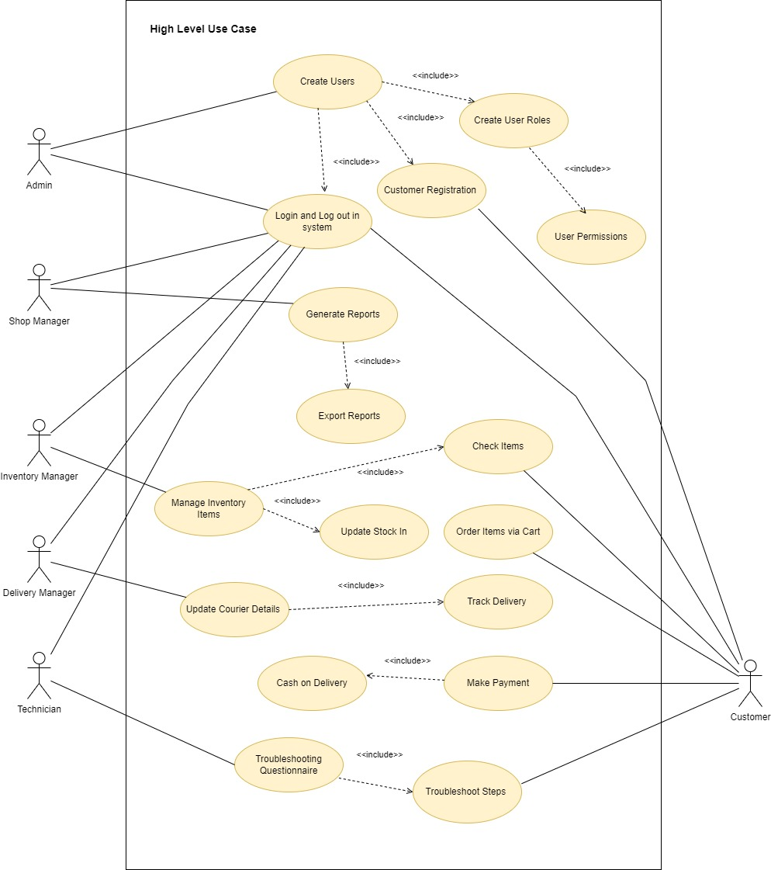

Figure 3. Proposed System Use Case Diagram

## 3.5 Use Case Narratives for the Proposed System

### 3.5.1 Use Case Narratives for Login Module

|  |  |  |
| --- | --- | --- |
| **Use-case Number** | UC-04 | |
| **Use-Case Name** | Login | |
| **Priority** | High | |
| **Actor** | Admin, Shop Manager, Inventory Manager, Delivery Manager, Technician, Customer | |
| **Description** | This use case describes how Shop Staff and Customers are logins to the System. | |
| **Precondition** | All actors are properly registered to the system. | |
| **Post-condition** | If the use case was successful, the actor is now logged into the system. If not, the system state is unchanged. | |
| **Basic course of Action** | **User Action** | **System Response** |
| 1. The Actor is on the login page to log in to the system.  3. The Actor enters his username and password and clicks on a Login Button. | 2. The system promotes the Actor to enter the Username and Password.  4. The system verifies that all the filled have been filled out and are valid.  5. The system successfully logged in the system.  6. Use case Exit |
| **Alternate course of Action** | 4.1 If all fields are not filled out and not matched to the username and password the system notifies the actor of a message “Invalid Username or Password” and then goes back or returns to step 3 of the basic course of Action to enter again. | |

Table 3. : Use Case Narrative for Login Module

### 3.5.2 Use Case Narratives for Insert Inventory Item

|  |  |  |
| --- | --- | --- |
| **Use-case Number** | UC-08 | |
| **Use-Case Name** | Insert Inventory Item | |
| **Priority** | High | |
| **Actor** | Inventory Manager | |
| **Description** | This use case describes how to manage items in the inventory | |
| **Precondition** | None | |
| **Post-condition** | If the use case was successful, the actor can add the product to the system and set it to sell to the customers. | |
| **Basic course of Action** | **User Action** | **System Response** |
| 1. Actor clicks the “Add Item” in the Item Management section.  3. Actor fill the fields (Item Image, Item Name, Category, Brand, Model, SKU number, Insert variable specifications, reorder level, Unit price, and Sale price)  4. Actor click “Insert Item” | 2. System prompts the form to insert details to the actor.  5. System validates the Item Name and SKU already in the system.  6. System display massage “New Item Insert” |
| **Alternate course of Action** | 5.1. If an item is already inserted into the system display the popup message “This Item Already in the System”. | |

Table 3. : Use Case Narrative for Inventory Item

## 3.6 ER Diagram for the Proposed System

The high-level ER Diagram below depicts the relationships between the proposed system's constituents. (Figure 3.2)

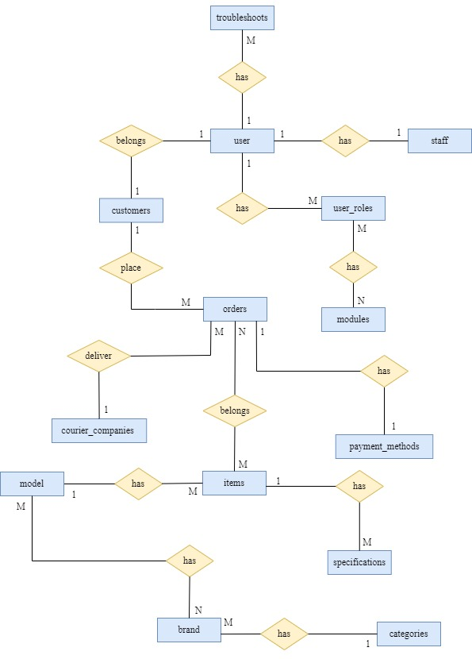  
  
Figure 3. : ER Diagram for Proposed System

## 3.7 Releational Shecma for System

* USERS (user_id, user_name, email, password, frist_name, last_name, profile_image, created_date, status*, user_role*, u_notification*)
* CUSTOMERS (cus_id, contact_number, postal_code, address_l1, address_l2, city, province, user_id*)
* STAFF (staff_id, nic, dob, contact_number, address_l1, address_l2, city, postal_code, user_id*, status*)
* USER_ROLES (user_role_id, role_name, status*)
* TROUBLESHOOTS (troub_id, trub_name, trub_discription, trub_video)
* MODULES (module_id, description, path, view, icon, status*)
* ORDERS (order_id, order_number, order_total, total_discount, grand_total, order_date, order_time, user_id*, delivery_charge*, payment_id*, courier_status*)
* PAYMENT_METHODS (id, name, discription)
* COURIERS_ COMPANIES (company_id, company_name, contact_number, contact_number_opp, email, address_line_1, address_line_2, tracking_url, status*)
* ITEMS (item_id, item_image, item_name, sku, reorder_level, grn_price, unit_price, sale_price, sale_price, discount_rate, item_discription, date, stock,warranty_period, category_id*, brand_id*, model_id*, status*)
* SPECIFICATIONS (spec_id, spec, category_id*, status*)
* MODELS (model_id, model_name,category_id*, status*)
* BRANDS (brand_id, brand_name, status*)
* CATEGORIES (category_id, category_name, category_discription, cat_image, status)

## 3.8 Activity Diagrams for the Proposed System

### 3.8.1 Activity Diagram for Login

The activity diagram for creating workouts is shown in Figure 3.3.

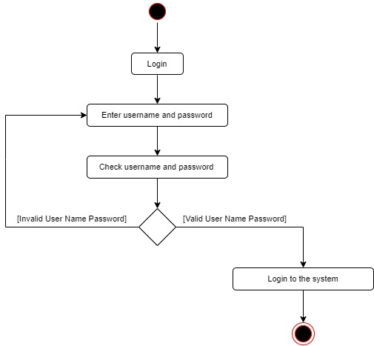  
  
Figure 3. : Activity Diagram for Login

### 3.8.2 Activity Diagram for Add Item

The activity diagram for adding a new item to the inventory is shown in Figure 3.4.

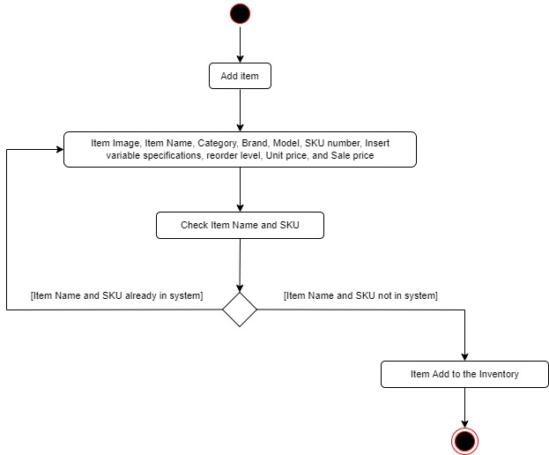  
  
Figure 3. : Activity Diagram for Add Item

## 3.9 – UI Designs for the Proposed System

### 3.9.1 – Customer Login Form UI Design

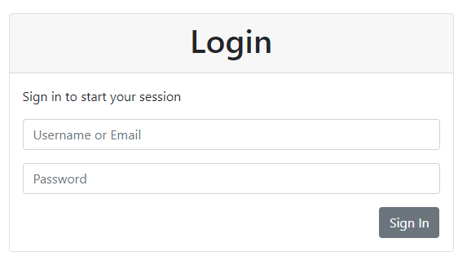

Figure 3. : Login Form UI Design

### 3.9.2 – Customer Register Form UI Design

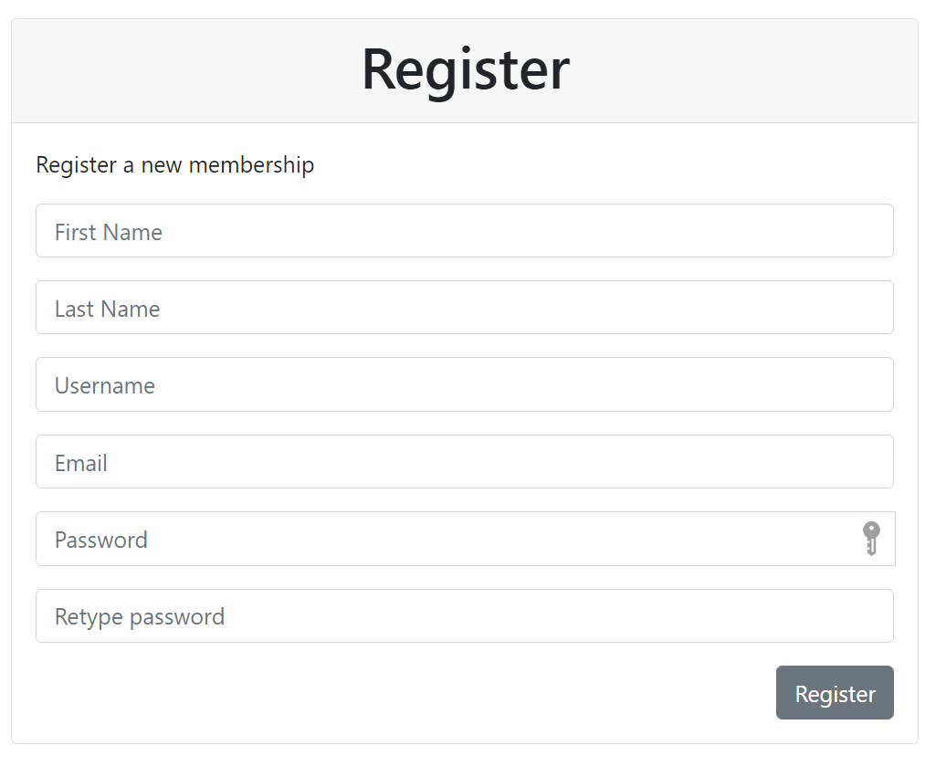

Figure 3. : Register Form UI Design

### 3.9.3 – Customer Checkout UI Design

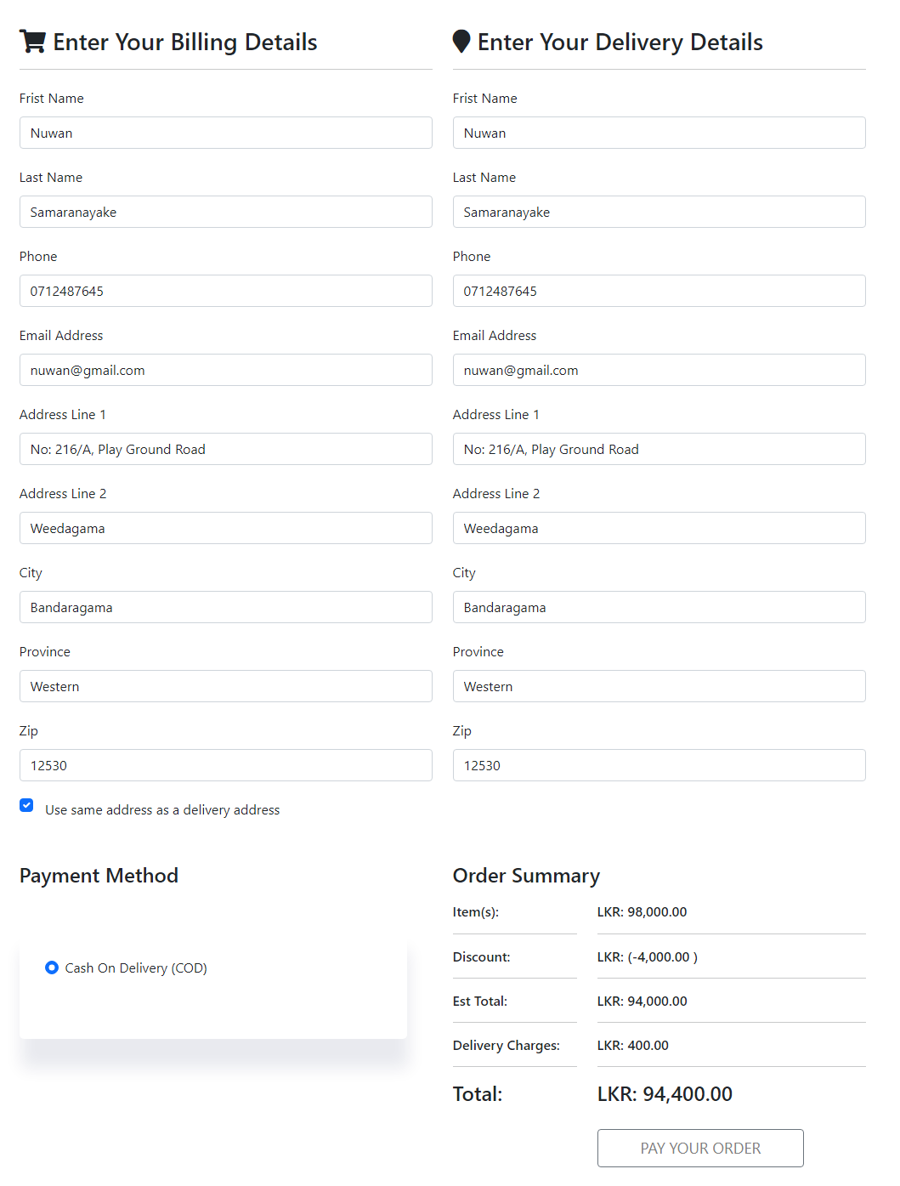

Figure 3. : Order Checkout form

### 3.9.3 – Add Inventory Item Form

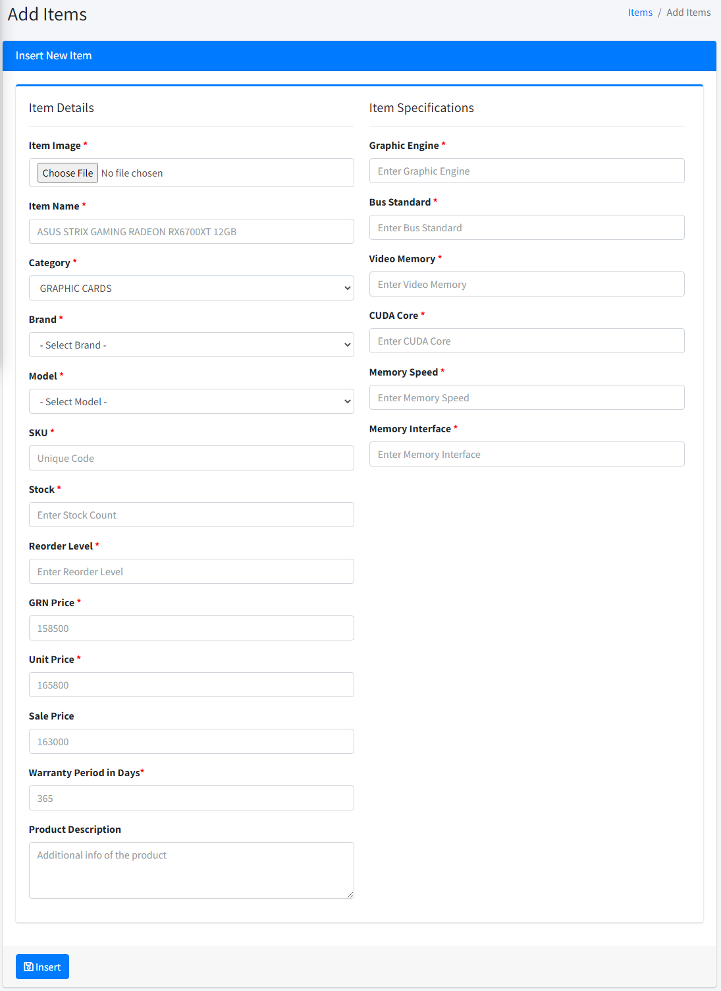

Figure 3. : Add Items form

# Chapter 4 – Implementation

## 4.1 – Chapter Introduction

In comparison to the previously described analysis and design of the system, implementation was the phase in which U-Star Digital carried out the developing and real-world testing of the Web-Based Computer Hardware Purchasing and Troubleshooting Assistant Management System. In order to maintain the system's quality and security, best practices were followed during implementation and development.

## 4.2 – Implementation Environment

There are two primary implementation environments for a system when it comes to implementation. There are two types of implementation environments: software and hardware. To keep implementation and maintenance costs low, it was mostly done with free and open-source software and tools. The tools and procedures utilized in this phase are listed below.

4.2.1 – Software EnvironmentThe work is done on a computer that runs the Microsoft Windows operating system. As a result, a software environment that is compatible with Windows was established. The XAMPP server was utilized because it comes with Apache, MySQL, and PHP on Windows. Visual Studio Code IDE has been used as the primary design tool for development. Visual Studio Code is an open-source integrated development environment (IDE) for programming languages such as Java, PHP, C++, and others. Bootstrap 5 is the most recent version of the most popular HTML, CSS, and JavaScript framework for creating responsive, mobile-first websites.

Although PHP is the primary development language, it is supported by several other languages.

* HTML – to create the web pages' content
* JavaScript – for content validation and filtering
* CSS – to make the web pages styles
* JQuery – Code libraries that can be reused
* Ajax – to make changes to the content without having to reload the page
* diagrams.net – to sketch a design diagram
* GanttPRO – to create a project timeline
* Microsoft Word – to compose a documents

### 4.2.2 – Hardware Environment

This system was created using a computer with the features shown in Figure 4.1.

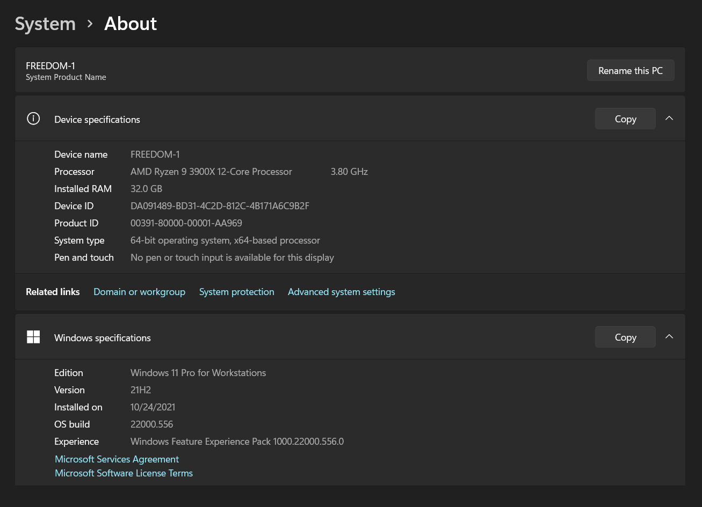

Figure 4. : Hardware Environment

4.2.3 – Other Softwares and Development ToolsWas used authoring tools such as Adobe Photoshop CC for designing graphics and web browsers such as Firefox, Google Chrome, and Internet Explorer for testing the system, in addition to software development tools.

## 4.3 – Justification for the choice of the implementation platform

* **Web Server**

The project's dedicated server, XAMPP Server, was utilized to manage the application using phpMyAdmin. The web server was handled by Apache, which is another part of its solution stack.

* **Database Server**

The software's database server was MySQL, which is also part of the XAMPP solution stack. MySQL is a relational database management system that is free and open-source.

* **PHP**

PHP, a server-side scripting language developed primarily for web development but also used as a general-purpose programming language, was used to construct the system.PHP is a popular, efficient, and free server programming language that may be used to create dynamic and interactive Web pages.

* **HTML**

HTML, which is the standard markup language for building web pages and web applications, was utilized as the system's basic web language.

* **CSS**The system was styled with CSS. CSS is a language for describing how an HTML document should appear.
* **Bootstrap 5**

Bootstrap is the most widely used HTML, CSS, and JS framework for creating responsive, mobile-first websites.

* **JavaScript**

JavaScript is a high-level, interpreted programming language that is utilized in the construction of the system for code validation and filtering.

* **JQuery**When employing reusable components, jQuery is a quick, compact, and feature-rich JavaScript library that was used to construct the system.
* **Microsoft Word**Microsoft Word, a simple text editor produced by Microsoft, was utilized.
* **Adobe Photoshop CC**Adobe Photoshop CC is a significant update that includes a new Object Selection Tool, improved Warp Transformation, updated Preset Library, and a slew of new keyboard shortcuts and timesavers.

4.3.1 System File StructureFigure 4.2 depicts the file structure of the produced system.

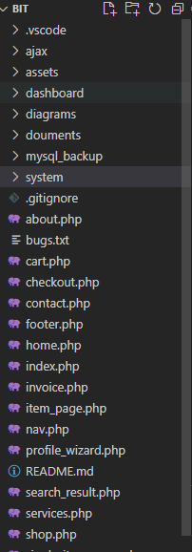

Figure 4. : File Structure

## 4.4 – High Level Module Structure

Inventory Management Module – Accessed by Inventory Manager  
Delivery Management Module – Accessed by Delivery Manager  
Report Management Module – Accessed by Shop Manager  
Troubleshooting Assistant Module – Accessed by Technician  
User Management Module – Accessed by Administrator

4.5 – Major Code Segments4.5.1 – Customer Registration Code Segments

* Member Registration Form

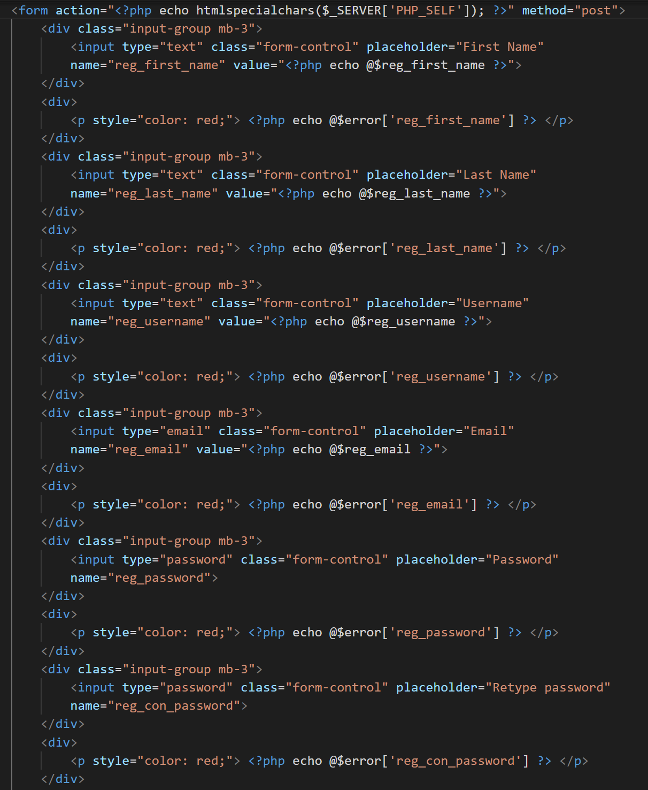

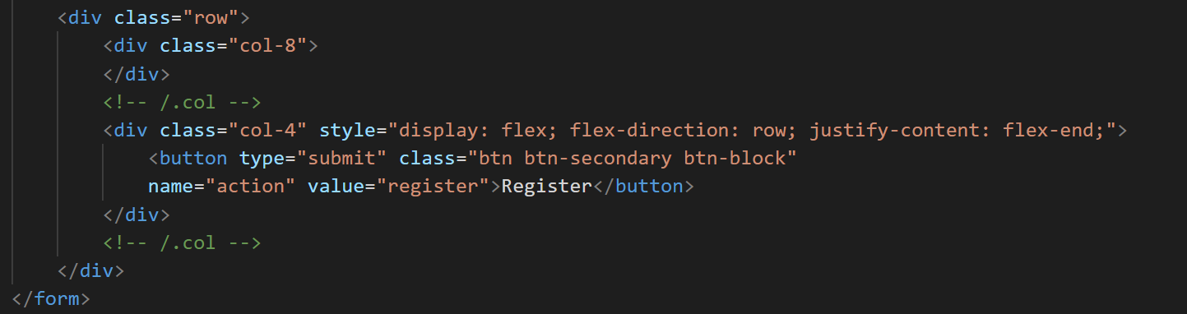

* Basic Validation of Customer Registration Form

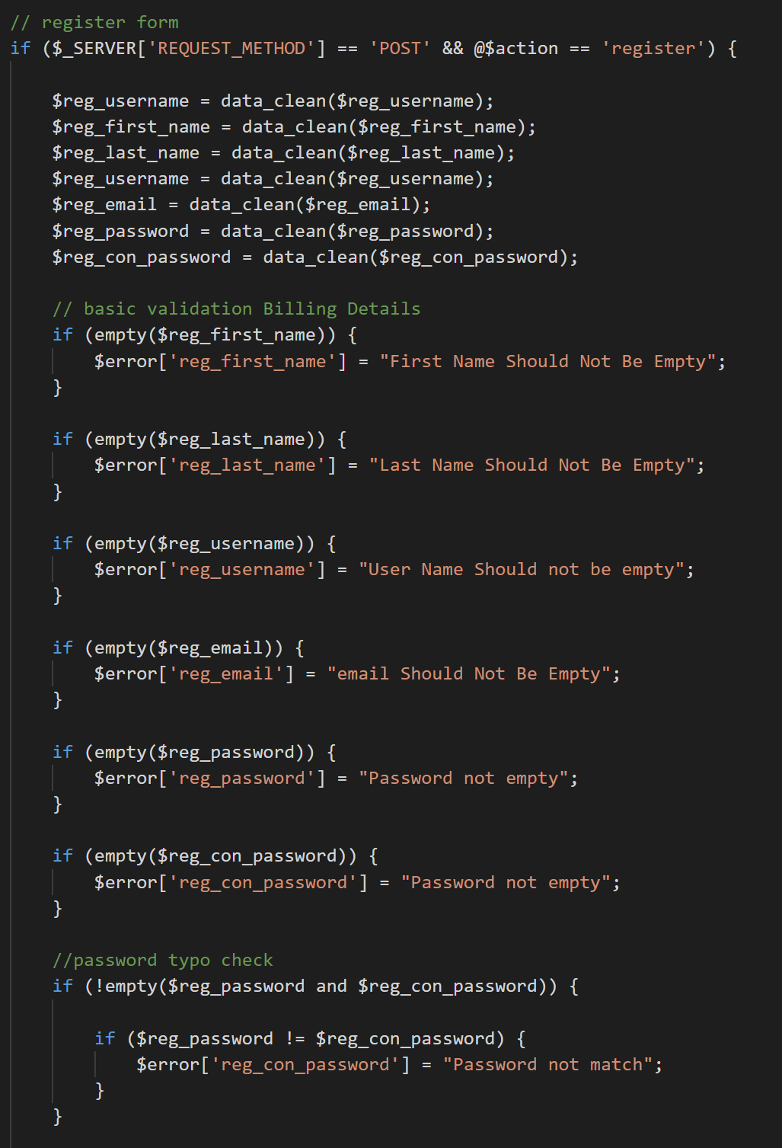

* Advance Validation of Customer Registration Form

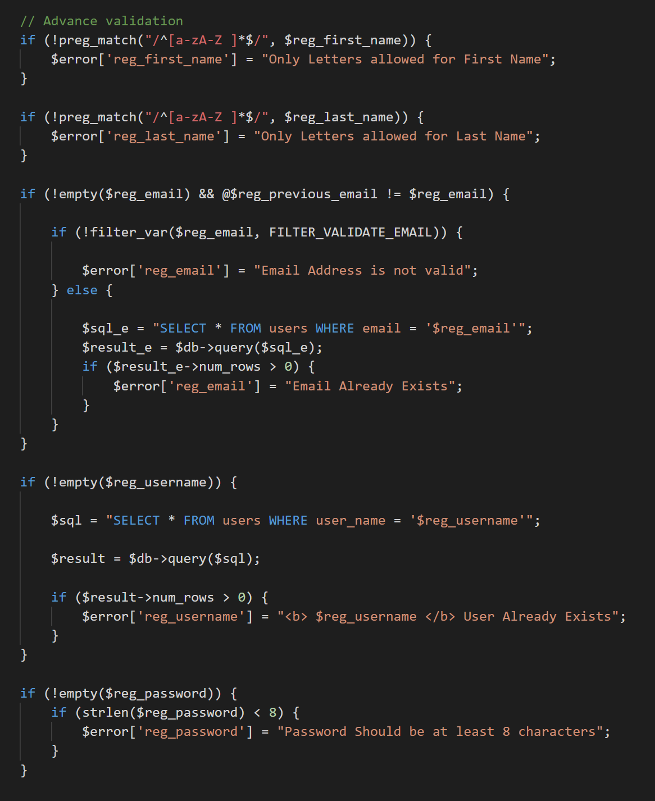

### 4.5.1 – Customer Checkout Code Segments

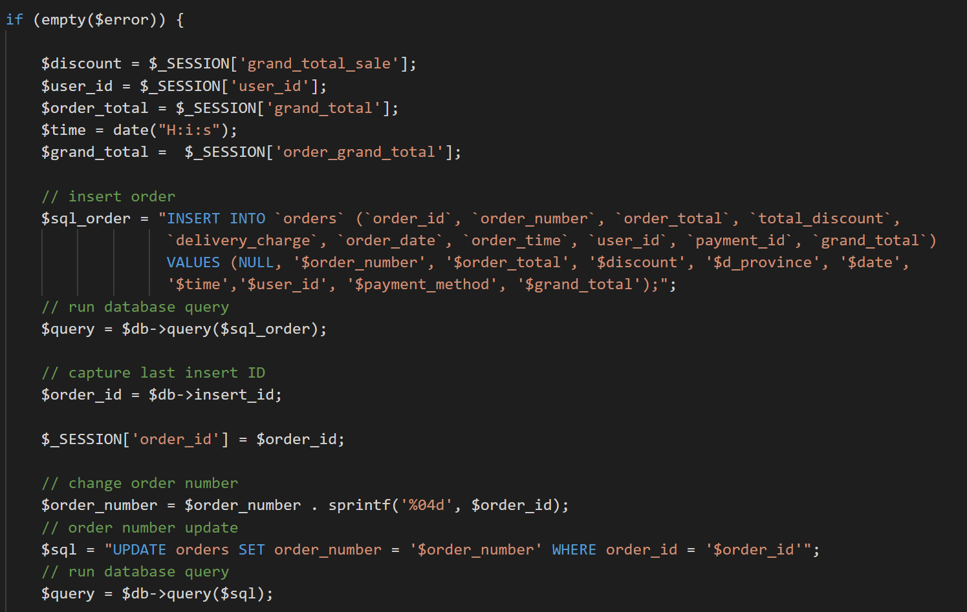

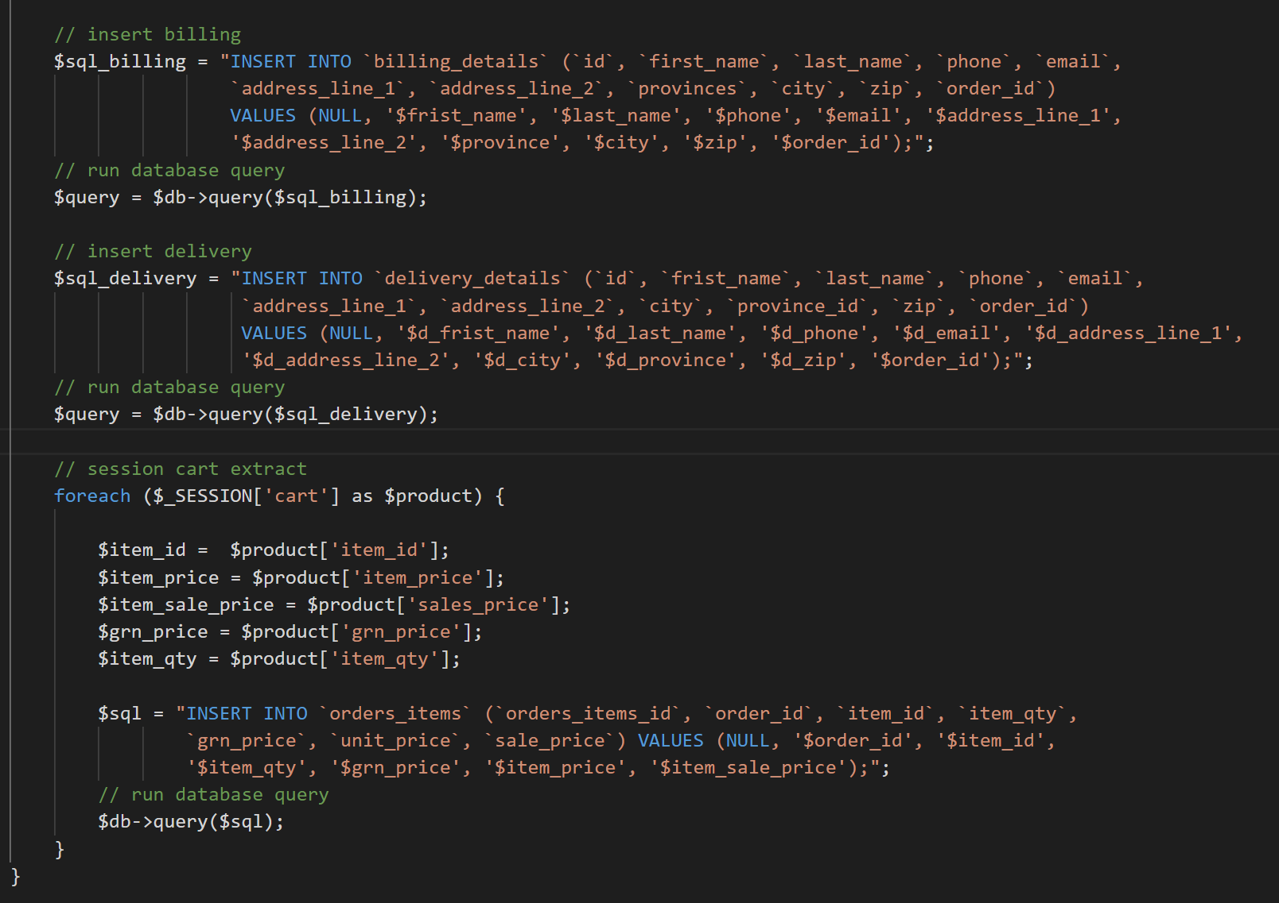

## 4.6 – Reused Existing Codes

When implementing the system, several of the well-tested re-usable components were added in order to maximize efficiency and provide more interest to the system.

* **Reusable CSS Files**

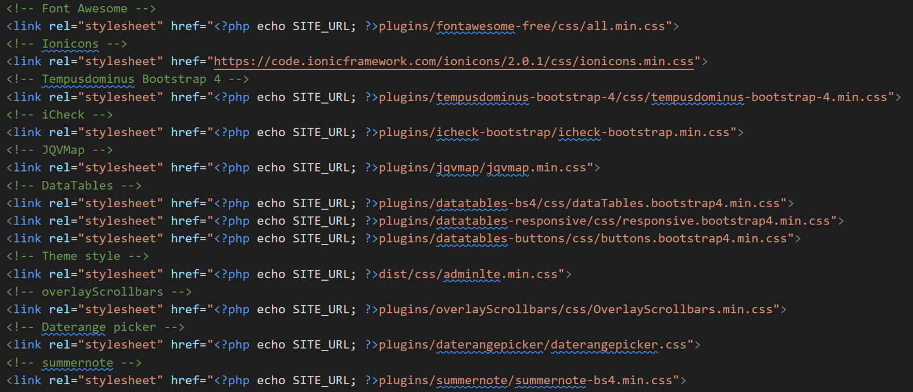

* **Reusable JavaScript Files**

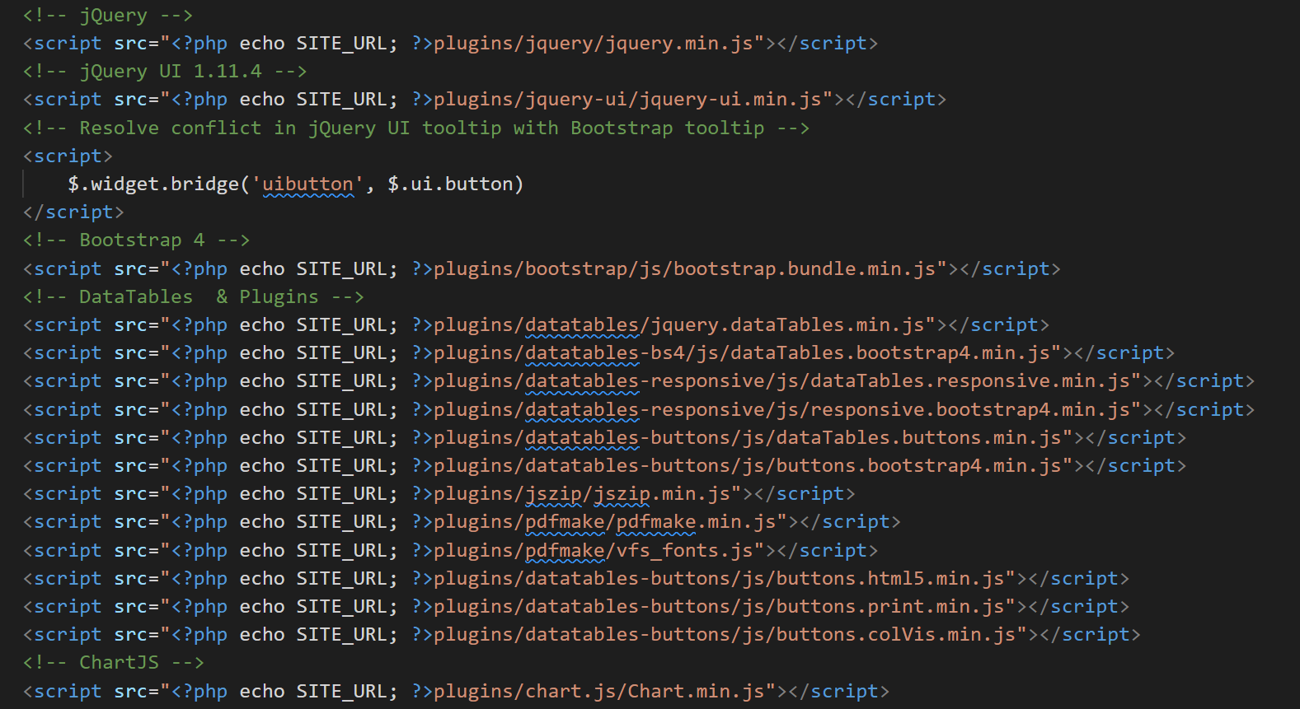

* **Reusable Image Upload Function**

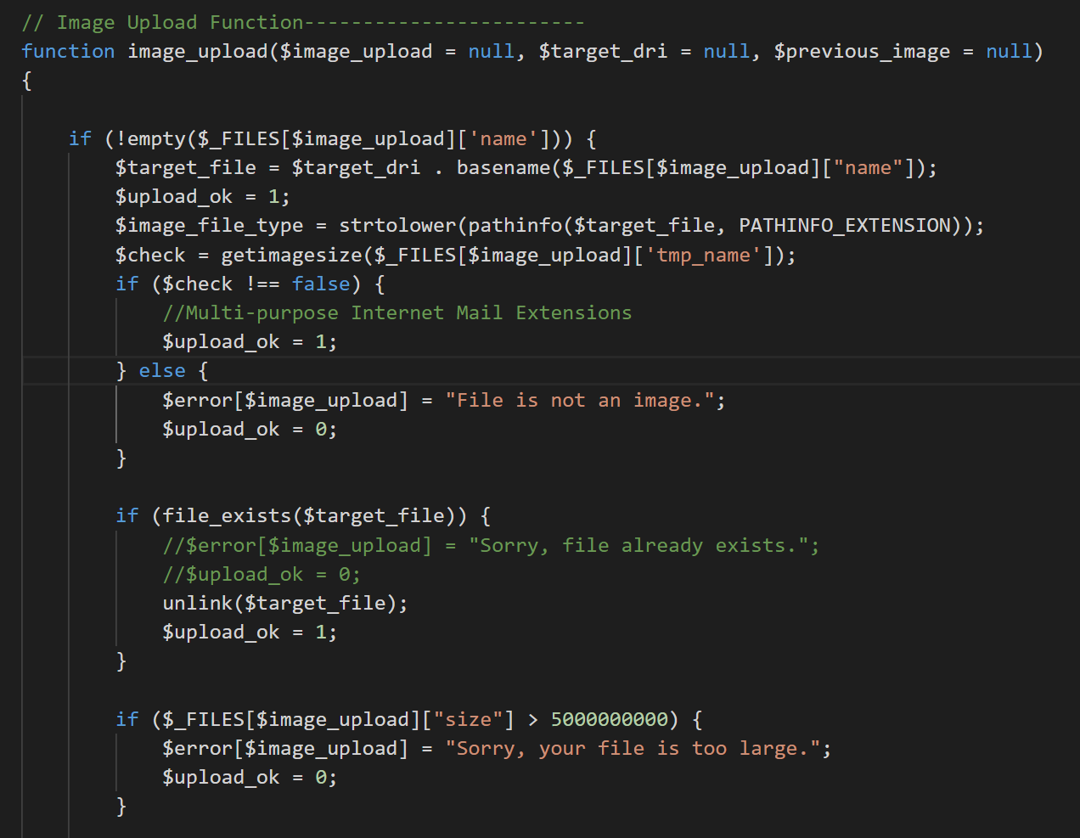

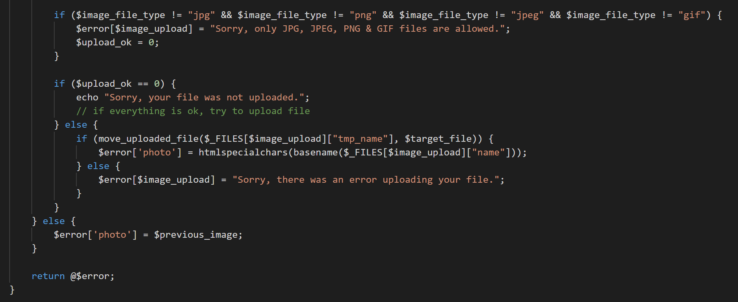

* **Reusable Data Clean Function**

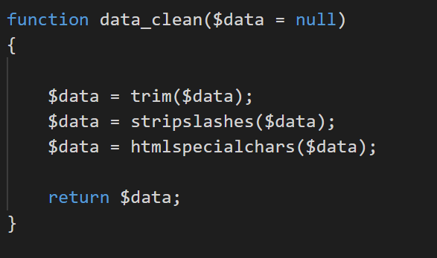

* **Reusable Main Menus Code in the Dashboard**

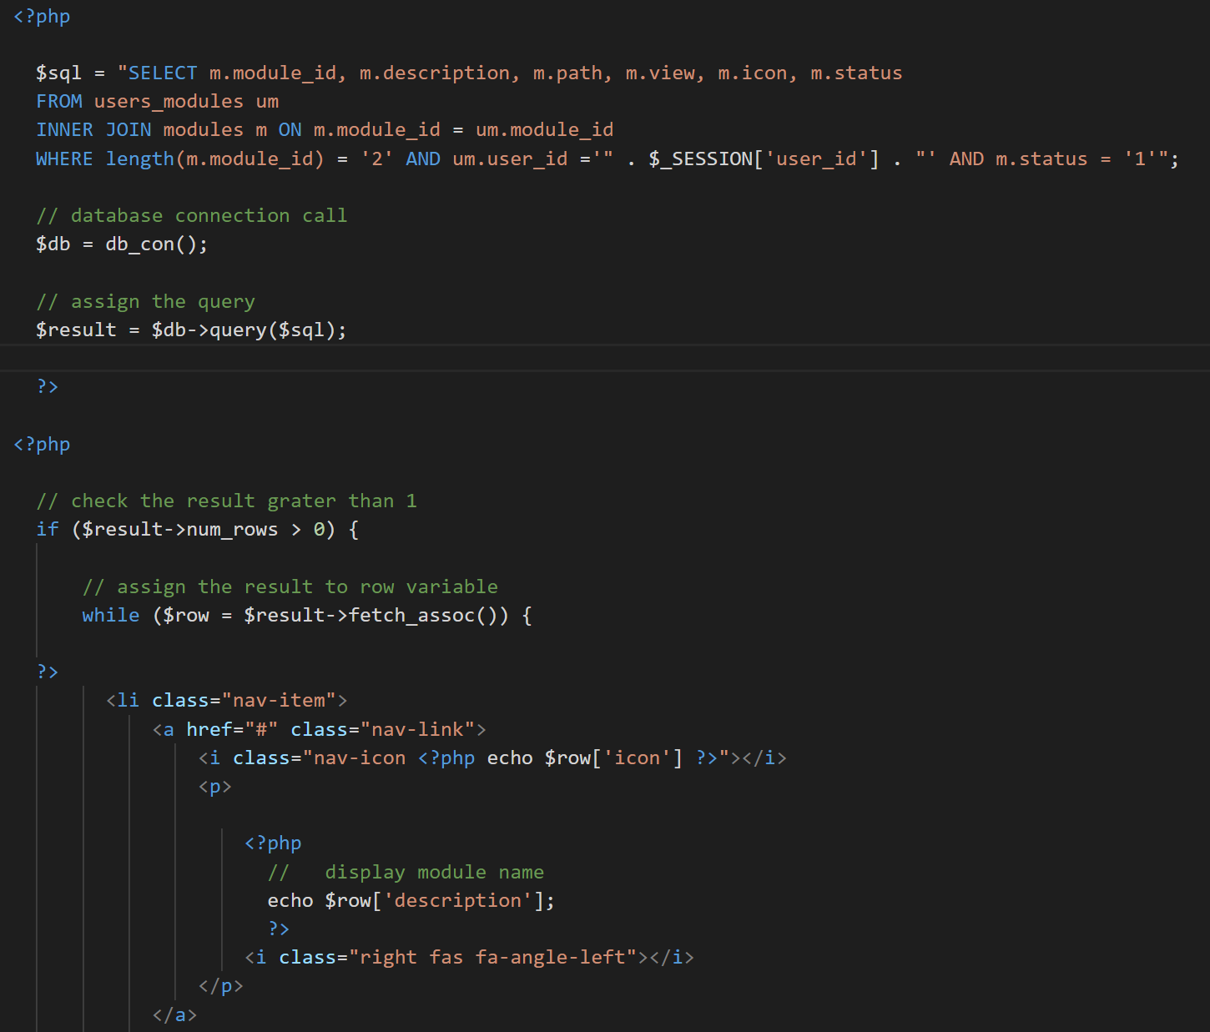

* **Reusable Sub Menus Code in the Dashboard**

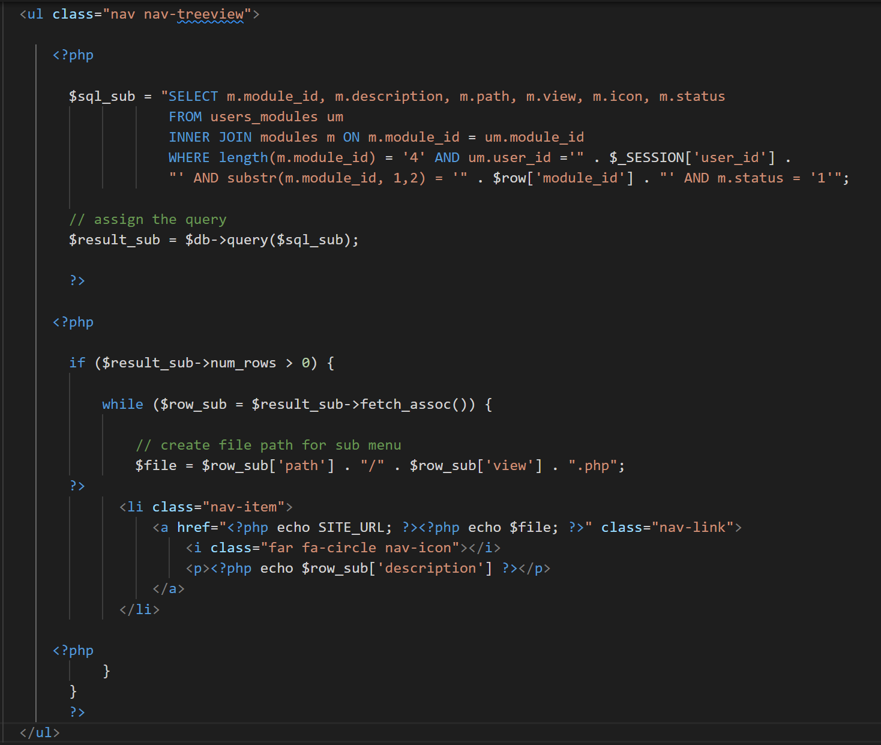

# Chapter 5 – Evaluation

## 5.1 – Introduction

The test plan, test results, and user evaluation are all described in the Evaluation chapter. To check and verify the system's performance, a wide range of data should be confirmed. During this step, the system's feature is assessed. The program is put through its paces in accordance with the test strategy.

## 5.2 - Description of testing approach

“A test approach is the test strategy implementation of a project, defines how testing would be carried out. Test approach has two techniques:

**Proactive** - An approach in which the test design process is initiated as early as possible in order to find and fix the defects before the build is created.

**Reactive** - An approach in which the testing is not started until after design and coding are completed.

There are many strategies that a project can adopt depending on the context and some of them are:

- Dynamic and heuristic approaches   
- Consultative approaches   
- Model-based approach that uses statistical information about failure rates.   
- Approaches based on risk-based testing where the entire development takes place based on the risk   
- Methodical approach, which is based on failures.   
- Standard-compliant approach specified by industry-specific standards.” [6]

## 5.3 - Test plan

“A Software Test Plan is a document describing the testing scope and activities. It is the basis for formally testing any software/product in a project. It describes the scope, approach, resources and schedule of intended test activities. It identifies amongst others test items, the features to be tested, the testing tasks, who will do each task, degree of tester independence, the test environment, the test design techniques and entry and exit criteria to be used, and the rationale for their choice, and any risks requiring contingency planning. It is a record of the test planning process.” [7]

### 5.3.1 - Verification and Validation

“Verification and Validation is the process of investigating that a software system satisfies specifications and standards and it fulfills the required purpose. Barry Boehm described verification and validation as the following:

**Verification:** Are we building the product right?

**Validation:** Are we building the right product?

Verification is the process of checking that a software achieves its goal without any bugs. It is the process to ensure whether the product that is developed is right or not. It verifies whether the developed product fulfills the requirements that we have. Validation is the process of checking whether the software product is up to the mark or in other words product has high level requirements. It is the process of checking the validation of product i.e. it checks what we are developing is the right product. it is validation of actual and expected product.” [8]

### 5.3.2 - Testing Process

1. **Unit testing**

Single units/components of the software are tested in unit testing, which is a type of software testing. The objective is to validate that each unit of the software functions as designed. A unit is the tiniest piece of software that can be tested.

1. **Integration Testing**

After unit testing, integration testing is performed, in which individual units are grouped together and tested as a group. This testing level's goal is to show problems in the interfaces and interactions between integrated components. Depending on the definition of a unit, either white-box or black-box testing can be used.

1. **System Testing**

System testing is a type of testing that is done on an entire integrated system to see if it meets its criteria. The black box testing approach is used to test the system's functionality from end to end during system testing.

1. **Acceptance Testing**

This was the last stage of the testing process before the system was put into service. Instead of using fictional test data, the system was tested with data provided by the system procurer. This is a product beta test conducted by genuine end-users.

1. **Regression Testing**

Regression testing is a sort of software testing used to ensure that a recent program or code modification hasn't broken current features. The major goal of this testing is to ensure that the system's existing functional and non-functional features have not been harmed by the recent changes.

5.4 - Proof of testing of work

The most significant component of this phase is creating test scenarios. Test cases that are well-planned should be able to validate system module functionality. All forms of system requirements must be validated by system test cases. The essential components of the test cases built for this system are listed below.

* **Test case for Customer Registration**

|  |  |  |  |
| --- | --- | --- | --- |
| **Test No** | **Test Case** | **Expected Result** | **Status** |
| 1 | Submit the form without filling in the mandatory fields. | Prevent submitting and show error messages | Pass |
| 2 | Use already exists username and email address | show error message | Pass |
| 3 | Invalid email insert | show error message | Pass |
| 4 | Incorrect Password length insert | show error message | Pass |
| 6 | Invalid phone number insert | show error message | Pass |
| 7 | Enter the numbers in the text fields | show error message | Pass |
| 8 | Invalid zip inserts | show error message | Pass |
| 9 | Submit the form with the correct data | Redirect to the login page | Pass |
| 10 | Without login URL browsing to the customer dashboard | Redirect to login page | Pass |

Table 5. : Test Case for Customer Registration

* **Test case for Customer Login**

|  |  |  |  |
| --- | --- | --- | --- |
| **Test No** | **Test Case** | **Expected Result** | **Status** |
| 1 | Enter a valid username and password | Successful login to the system | Pass |
| 2 | Enter username only | show error message | Pass |
| 3 | Enter only password | show error message | Pass |
| 4 | Enter invalid username and password | show error message | Pass |

Table 5. : Test Results for Customer login

* **Test case for Checkout Process**

|  |  |  |  |
| --- | --- | --- | --- |
| **Test No** | **Test Case** | **Expected Result** | **Status** |
| 1 | Submit the form without filling in the mandatory fields. | Prevent submitting and show error messages | Pass |
| 2 | Enter the numbers in the text fields | show error message | Pass |
| 3 | Invalid email insert | show error message | Pass |
| 4 | Invalid phone number insert | show error message | Pass |
| 5 | Invalid zip inserts | show error message | Pass |
| 6 | Without check the delivery check box | Show error message of delivery form | Pass |
| 7 | Without selecting the payment method | Show error message | Pass |
| 8 | Change the delivery value related to the province | Show delivery charges and calculate to total | Pass |
| 9 | Submit the form with the correct data | direct to the invoice page | Pass |
| 10 | Without login URL browsing to the checkout and invoice | Redirect to the cart page | Pass |

Table 5. : Test Result for Checkout Process

## 5.5 - User Acceptance Testing

“User Acceptance Testing (UAT), also known as beta or end-user testing, is defined as testing the software by the user or client to determine whether it can be accepted or not. This is the final testing performed once the functional, system and regression testing are completed.

The main purpose of this testing is to validate the software against the business requirements. This validation is carried out by the end-users who are familiar with the business requirements.

UAT, alpha and beta testing are different types of acceptance testing.

As the user acceptance test is the last testing that is carried out before the software goes live, obviously this is the last chance for the customer to test the software and measure if it is fit for the purpose.” [9]

## 5.6 - User Evaluation

User evaluation is an evaluation based on user input, that is, an evaluation that includes those for whom the system has suggested users. Probable methods, observational methods, questionnaires, interviews, and physiological monitoring methods are all examples of user evaluation procedures. Different sorts of users with varying levels of access privileges were selected and included in the sample, and user evaluation questionnaires were distributed to gather input.

Figure 5.1 depicts an example evaluation questionnaire for testing user satisfaction, figure 5.2 depicts a user acceptance test evaluation sample, and figure 5.3 depicts the system's user feedback results analysis diagram.

|  |  |  |  |  |  |  |  |  |  |  |  |  |  |  |  |  |  |  |  |  |  |  |  |  |  |  |  |  |  |  |  |  |  |  |  |  |  |  |  |  |  |  |  |  |  |  |  |  |  |  |  |  |  |  |  |
| --- | --- | --- | --- | --- | --- | --- | --- | --- | --- | --- | --- | --- | --- | --- | --- | --- | --- | --- | --- | --- | --- | --- | --- | --- | --- | --- | --- | --- | --- | --- | --- | --- | --- | --- | --- | --- | --- | --- | --- | --- | --- | --- | --- | --- | --- | --- | --- | --- | --- | --- | --- | --- | --- | --- | --- |
| **User Feedback Form – Computer Hardware Purchasing and Troubleshooting Assistant Management System for U-Star Digital**  Role of User: ………………………………….  Test Date: ………………………………………  Mark (✔) inside the box. Please provide a more comprehensive response with your honest option.   |  |  |  |  |  | | --- | --- | --- | --- | --- | | No | Description | Exceptional | Satisfied | Bad | | 1 | User interface design |  |  |  | | 2 | system's response time |  |  |  | | 3 | Form validation |  |  |  | | 4 | Understandability of error messages |  |  |  | | 5 | Interaction with navigation links and buttons |  |  |  | | 6 | system's responsiveness |  |  |  | | 7 | Report generating capability |  |  |  | | 8 | Recognizing the system's design |  |  |  | | 9 | Efficiency of the functionalities |  |  |  | | 10 | Overall impressions of the system |  |  |  |   Thank You |

Figure 5. : User Feedback Form

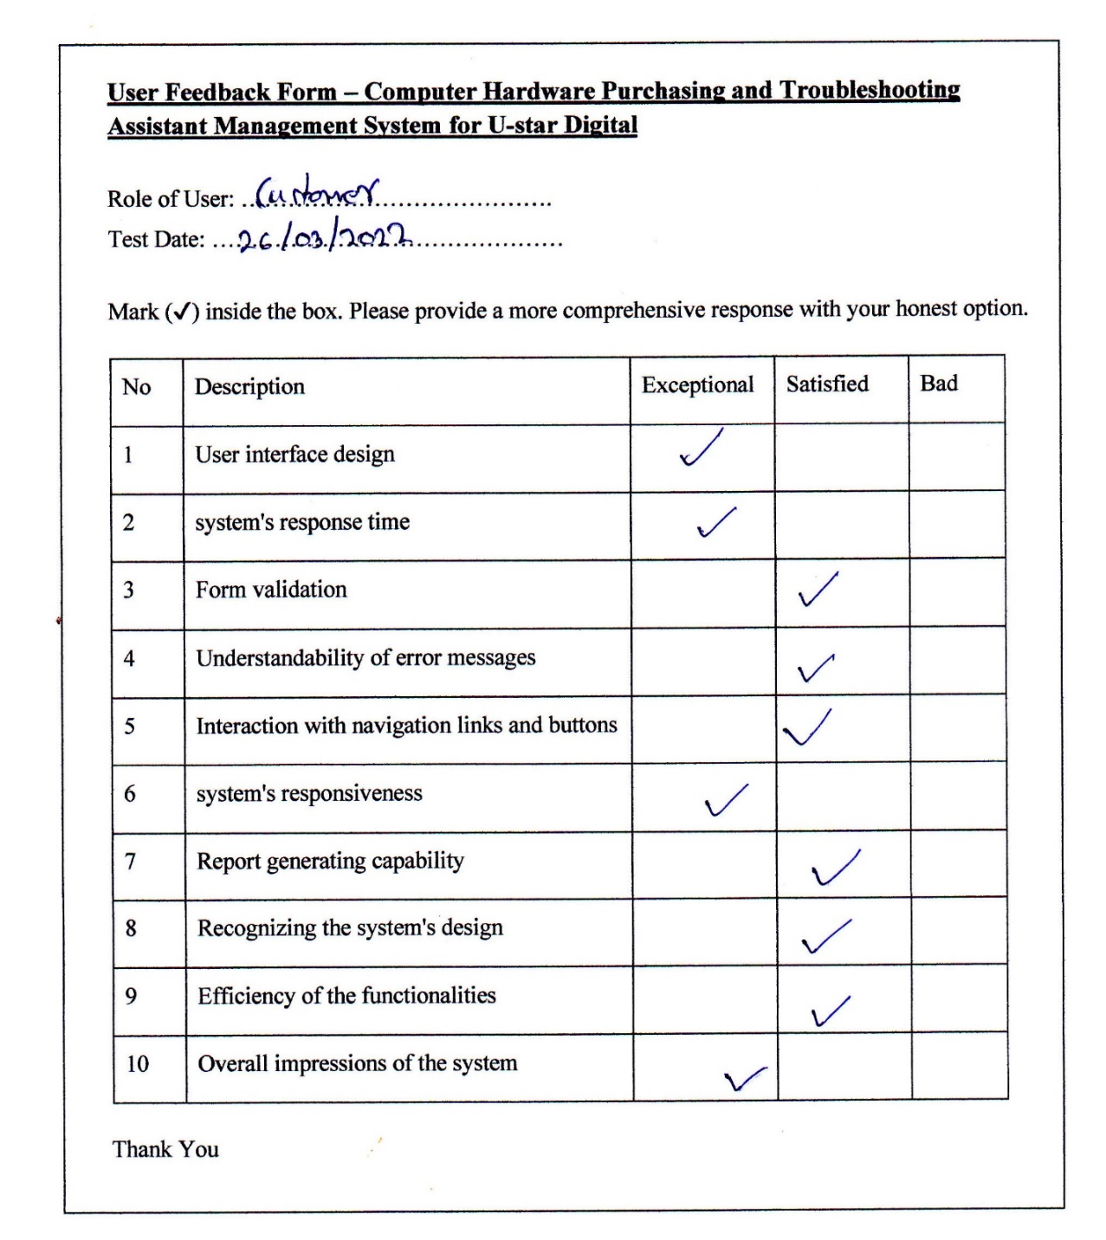

Figure 5. : User Acceptance Test Evaluation Sample

Figure 5. : Summary of User Feedback Evaluation

# Chapter 6 – Conclusion

## 6.1- Introduction

This chapter highlights the lessons learned while working on the U-Star Digital project to design a Computer Hardware Purchasing and Troubleshooting Assistant Management System. It also makes suggestions for future improvements to the system's performance and usability.

## 6.2 - Critical evaluation of the project

U-Star Digital currently does not have a system in place to link its shopping operations. To capture client information, their employees use spreadsheet programs and manual (paper papers). There is less integrity, the workload for the staff and their clients is high, inaccurate data levels occur, and all procedures are highly slow, time-consuming, and difficult to manage due to the use of paper documents and spreadsheets for data recording and data analysis.

The proposed solution was created to address those flaws while also improving their entire business process. The system was created with the most up-to-date development standards and technology in mind, as well as the requirement to expand and improve the business and the system in the future.

All the project's objectives were met exactly according to the client's specifications. End-user needs were gathered and examined before being transformed into a design model. For user engagement, the system's planned user interface was maintained basic and clear. After conducting a system evaluation, the system's weak points, flow, and errors were validated and verified. It was easy to determine whether the solution was a success and got the customer up to a satisfactory level by looking at user input and test results.

Finally, the client was satisfied with every module of the Web-Based Computer Hardware Purchasing and Troubleshooting Assistant Management System's functionality.

## 6.3 - Lesson learned

This project was the first time I had worked on a real-world project. As a student who took on this project, this software development has provided me with a wealth of programming expertise. During the system's implementation, the programming skills learned in the previous semesters were put to use in a real-world setting.

Working on a project allowed me to obtain and improve soft skills including communication, creative thinking, logical thinking, decision making, positivism, motivation, problem-solving, understandability, writing skills, self-learning, researching skills, self-confidence, and so on.

## 6.4 - Future work

The customer can now manage and thus run the complete task in a lot better, more accurate, and error-free manner now that the planned software is available and fully functional. The following is the project's future scope.

* **Creating a Mobile Application**

Users will be able to access and use the system more readily on their mobile devices thanks to the development of an interactive mobile application for this system.

* **Integrating the Internet payment gateway**

Customers are allowed to make payments more readily if they have access to an internet payment gateway.

* **AI Base Troubleshooting Assistant**

Implementing an artificial intelligence-based troubleshooting assistant that crawls the database and answers to provide the best response for the specified inquiry.

* **Computer Hardware Assistant**

Implimenting this module assists customers who are unfamiliar with computer hardware. It takes all the details of individual items and matches them with the next most appropriate piece, and completes the assembly of an entire computer. After completing, customers have an option to check out the selected parts and make a payment to complete the assistant process.

# References

[1] Micro Center, “About Micro Center”, <https://www.microcenter.com/>, [Online].

Available: <https://www.microcenter.com/site/content/about_microcenter.aspx>

[Accessed: 18.12.2021].

[2] newegg, “About Newegg corporate site”, <https://www.newegg.com/>, [Online].

Available: <https://www.newegg.com/corporate/about>

[Accessed: 18.12.2021].

[3] T. Alspaugh, “Software Process Models”, [www.thomasalspaugh.org](http://www.thomasalspaugh.org), [Online].

Available: <https://www.thomasalspaugh.org/pub/fnd/softwareProcess.html#scrum>

[Accessed: 22.01.2022].

[4] Agile Alliance, “What is extreme programming”, <https://www.agilealliance.org/> [Online]. Available: <https://www.agilealliance.org/glossary/xp>

[Accessed: 22.01.2022].

[5] Techterms.com, “RUP (Rational Unified Process) Definition”, <https://techterms.com/> [Online].

Available: <https://techterms.com/definition/rup>

[Accessed: 22.01.2022].

[6] “Test Approach Description”, https://www.tutorialspoint.com/ [Online].

Available: <https://www.tutorialspoint.com/software_testing_dictionary/test_approach.htm>

[Accessed: 18.02.2022].

[7] Test plan, in software testing fundamentals, “Test Plan”, [Online].

Available: <https://softwaretestingfundamentals.com/test-plan>

[Accessed: 19.02.2022].

[8] “Software Engineering | Verification and Validation”, [Online].

Available: <https://www.geeksforgeeks.org/software-engineering-verification-and-validation/>

[Accessed: 19.02.2022].

[9] A Complete Guide, “User Acceptance Testing”, www.softwaretestinghelp.com [Online].

Available: https://www.softwaretestinghelp.com/what-is-user-acceptance-testing-uat/

[Accessed: 20.02.2022].

# Appendix A – System Manual

This manual provides step-by-step instructions on how to correctly install, set up, configure, and run the system for U-Star Digital.

**Step 01**

According to table A.1 and table A.2, the hardware and software requirements are listed below.

**Hardware Requirements**

|  |  |
| --- | --- |
| **Hardware** | **Requirements** |
| Processor | Intel(R) Core(TM) i3-5005U CPU @ 2.00GHz |
| Memory | 2GB or Above |
| Storage | 25GB |
| Display | 1366 x 768 Resolution Monitor |
| Internet | 4 mbps internet connection |

Table A. : Hardware Requirements

**Software Requirements**

|  |  |
| --- | --- |
| **Hardware** | **Requirements** |
| Operating System | Microsoft Windows 7 or Above Operating System |
| Web Server | XAMPP release 7.3.33 , 7.4.26 |
| Web Browser | Chromium based web browsers / Firefox |
| Code Editor | Microsoft Visual Studio Code / Notepad++ |

Table A. : Software Requirements

**Step 02**

1. Downloading XAMPP Server
   1. WAMP Server can be downloaded and installed from the following URL. <https://www.apachefriends.org/download.html> (Figure A.1)
   2. Download the appropriate WAMP Server version.
   3. When installing WAMP Server on your computer, follow the instructions on the WAMP Server installation web page.

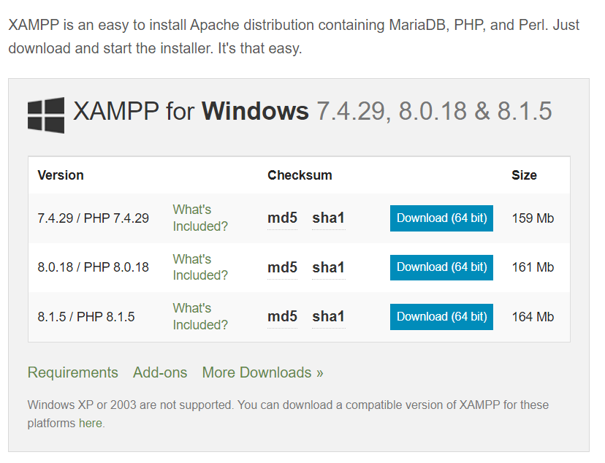

Figure A. : XAMMP Server Download Page

1. Installing XAMPP Server
   1. Run the XAMPP Server execution file that you downloaded (.exe).
   2. Deactivate UAC
   3. Choose a location to install the WAMP Server and proceed to install.
   4. Double-click on the XAMPP icon to launch the server. The server will then be started by clicking the start button.
   5. Start “Apache” and MySQL modules by clicking on the “Start” button.

**Step 03**

1. Create the Database
   1. Open the web browser and type <http://localhost/phpmyadmin>.
   2. If you want to set a password, log in to the database and enter a username "root" and password.
   3. Create the database with the name “db_ustar” (Figure A.2).

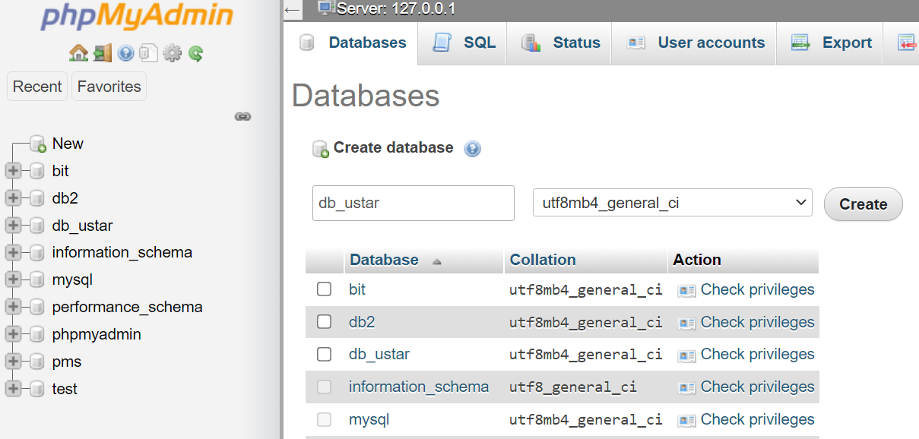

Figure A. : Create Database

1. Import Database File
   1. Select created database and click on the “import” tab
   2. Navigate to the database folder on the CD and find the "db ustar.sql" file.
   3. Click the Go button.
2. Store the System File
   1. Navigate to the folder where the XAMPP server was installed.
   2. Locate the “htdocs” folder.
   3. Copy the "u_star_system.zip" file from the given CD.
   4. Copy the file and paste it into the htdocs folder to unzip it.
3. Launching the System
   1. Type [http://localhost/ustar/](http://localhost/ustar/system/) to launch the system in your browser
   2. Type <http://localhost/ustar/system/> to login to the system in your browser.

# Appendix B – Design Documentation

The following diagrams represent a few other significant system functionalities, in addition to the data modelling diagrams in Chapter 03 of the dissertation.

**Use Case Diagrams**

A use case diagram is a visual representation of the relationships between the components of a system. A use case is a system analysis methodology for identifying, clarifying, and organizing system needs. The system's actors are divided into groups based on their roles.

* **Use – Case Diagram for Customer Registration**

The use case diagram for customer registration is given in Figure B.1 and the use case narrative for customer registration is given in Table B.1.

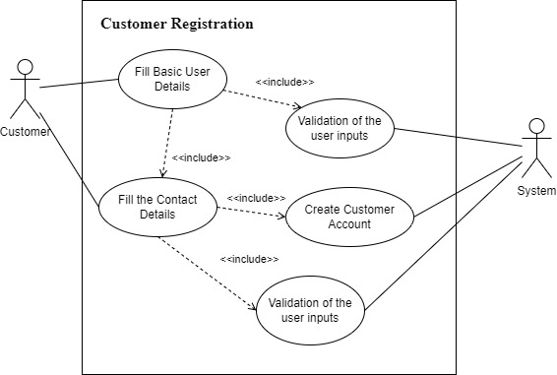

Figure B. : Use Case Diagram for Customer Registration

|  |  |  |
| --- | --- | --- |
| **Use-case Number** | UC-02 | |
| **Use-Case Name** | Customer Registration | |
| **Priority** | High | |
| **Actor** | Customer | |
| **Description** | This use case describes the process of registering customers with the system. | |
| **Precondition** | None | |
| **Post-condition** | The actor is directed to the customer login page to log in to the system if the use case was successful. | |
| **Basic course of Action** | **User Action** | **System Response** |
| 1. The Actor is on the My Account page to register as a customer.  3. The Actor fills out the form and clicks the Register button.  6. The Actor fills out the form and clicks the Done button. | 2. The system promotes the form to enter user details.  4. The system verifies that all the filled have been filled out and are valid.  5. All fields are valid system navigates to the complete profile page.  6. The system verifies that all the filled have been filled out and are valid.  7. System navigate to the My Account page to log in to the system.  8. Use case Exit |
| **Alternate course of Action** | 4.1 If all fields are not filled out and already taken by another customer the system notifies the actor and then goes back or returns to step 3 of the basic course of Action to enter again.  5.1 If all fields are not filled out and already taken by another customer the system notifies the actor and then goes back or returns to step 3 of the basic course of Action to enter again. | |

Table B. : Use Case Narrative for Customer Registration

* **Use – Case Diagram for Order Checkout**

Use case diagram for order checkout is given in Figure B.2 and use case narrative for order chekout is given in Table B.2.

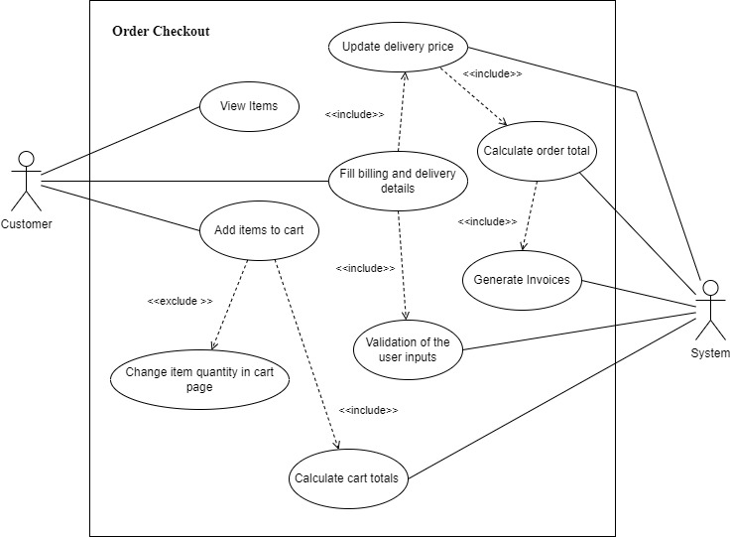

Figure B. : Use Case Diagram for Order Checkout

|  |  |  |
| --- | --- | --- |
| **Use-case Number** | UC-03 | |
| **Use-Case Name** | Order Checkout | |
| **Priority** | High | |
| **Actor** | Customer | |
| **Description** | This use case describes the process of checkout selected items in the shopping cart. | |
| **Precondition** | Need to add items to the cart | |
| **Post-condition** | When the process is completed successfully, the actor is directed to the invoicing page. | |
| **Basic course of Action** | **User Action** | **System Response** |
| 1. The Actor view and adds items to the cart.  2. Actor clicks cart icon in navigation.  5. The Actor clicks the checkout order button.  7. Actor fill the details of delivery and billing details forms and check the payment method and click the place your order button. | 3. System display all items added to the cart by the actor.  4. System calculates the item total price without delivery price.  6. System prompt billing details, delivery details forms, and payment methods.  8. System validates the actors input and redirects to the order invoice page. |
| **Alternate course of Action** | 5.1 If the Actor can change the cart item quantity, the system calculates the item total and cart total regarding to the item quantity.  5.2 If the Actor does not login to the system, the checkout page displays the login and register form  7.1 Actor needs to check the checkbox for delivery to the same billing address.  8.1 If the form is not validated properly system shows the error messages. | |

Table B. : Use Case Narrative for Order Checkout

**Activity Diagrams**

The activity diagram, which is essentially a flowchart to show the flow from one activity to the next, is an important diagram in UML to explain the dynamic aspects of the system. The activity can be characterized as a system operation.

* **Activity diagram for Customer Registration**

The activity diagram for customer login is given in Figure B.3

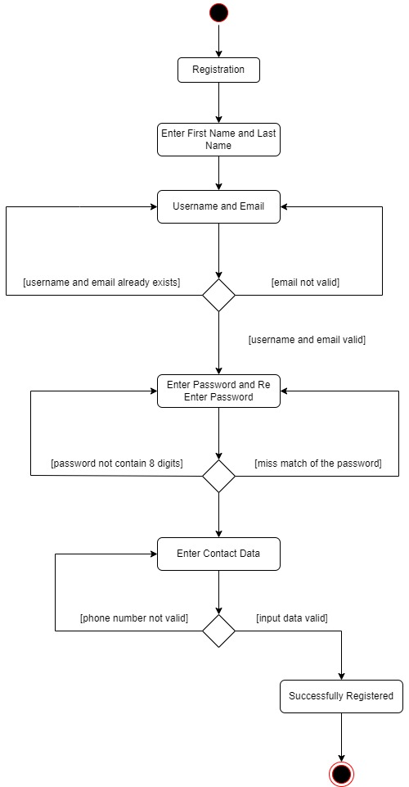

Figure B. : Activity Diagram for Customer Login

* **Activity diagram for** **Order Checkout**

The activity diagram for order checkout is given in Figure B.4

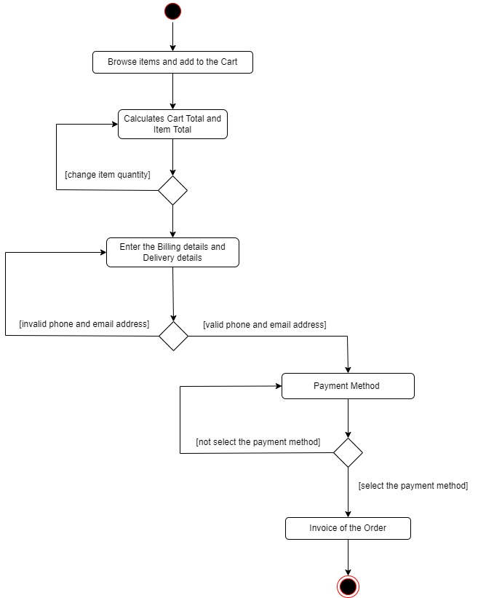

Figure B. : Activity Diagram for Order Checkout

# Appendix C – User Manual

By covering essential aspects, this manual provides the necessary instructions for Customers, Administrators, Shop Managers, Inventory Managers, Delivery Managers, and Technicians to interact with the system. This section's ultimate purpose is to make the user aware of the system's major features so that they can get the most out of it. Despite the fact that the system describes several user-level privileges, the key modules of the standard user role, as well as some administrator configuration options, are briefly detailed below.

**User Manual Part 1**

**User: Customer**

By entering the URL <http://localhost/ustar/> you can browse the home page of the U-Star Digital website (Figure C.1). Following the selection of the option, the consumer can proceed with the standard computer hardware shopping cart process as depicted in (Figure C.2) (Figure C.3) (Figure C.4) (Figure C.5) (Figure C.6) (Figure C.7)

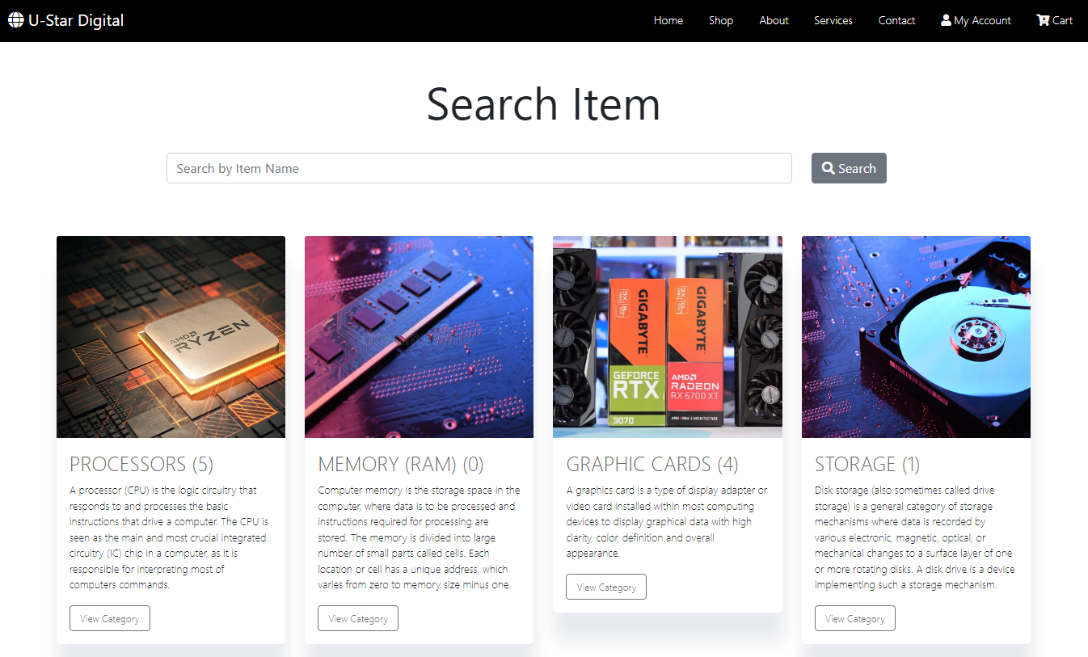

Figure C. : Home Page

Customers can start the shopping experience by selecting the category.

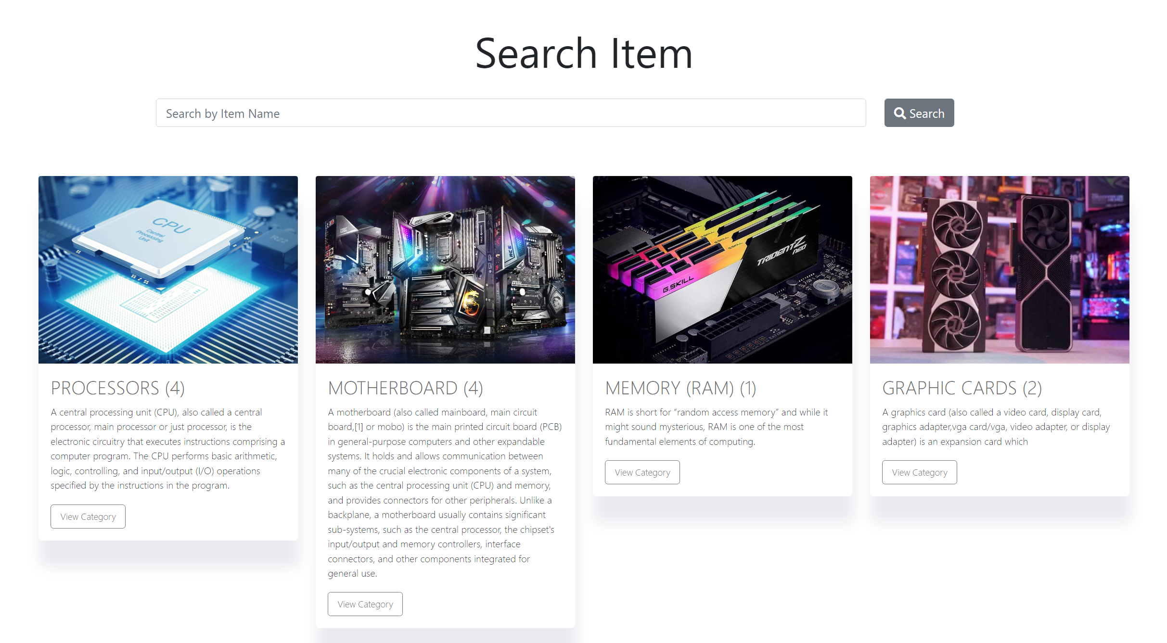

Figure C. : Category Page

After selecting a category customers can view the selected category product listing.

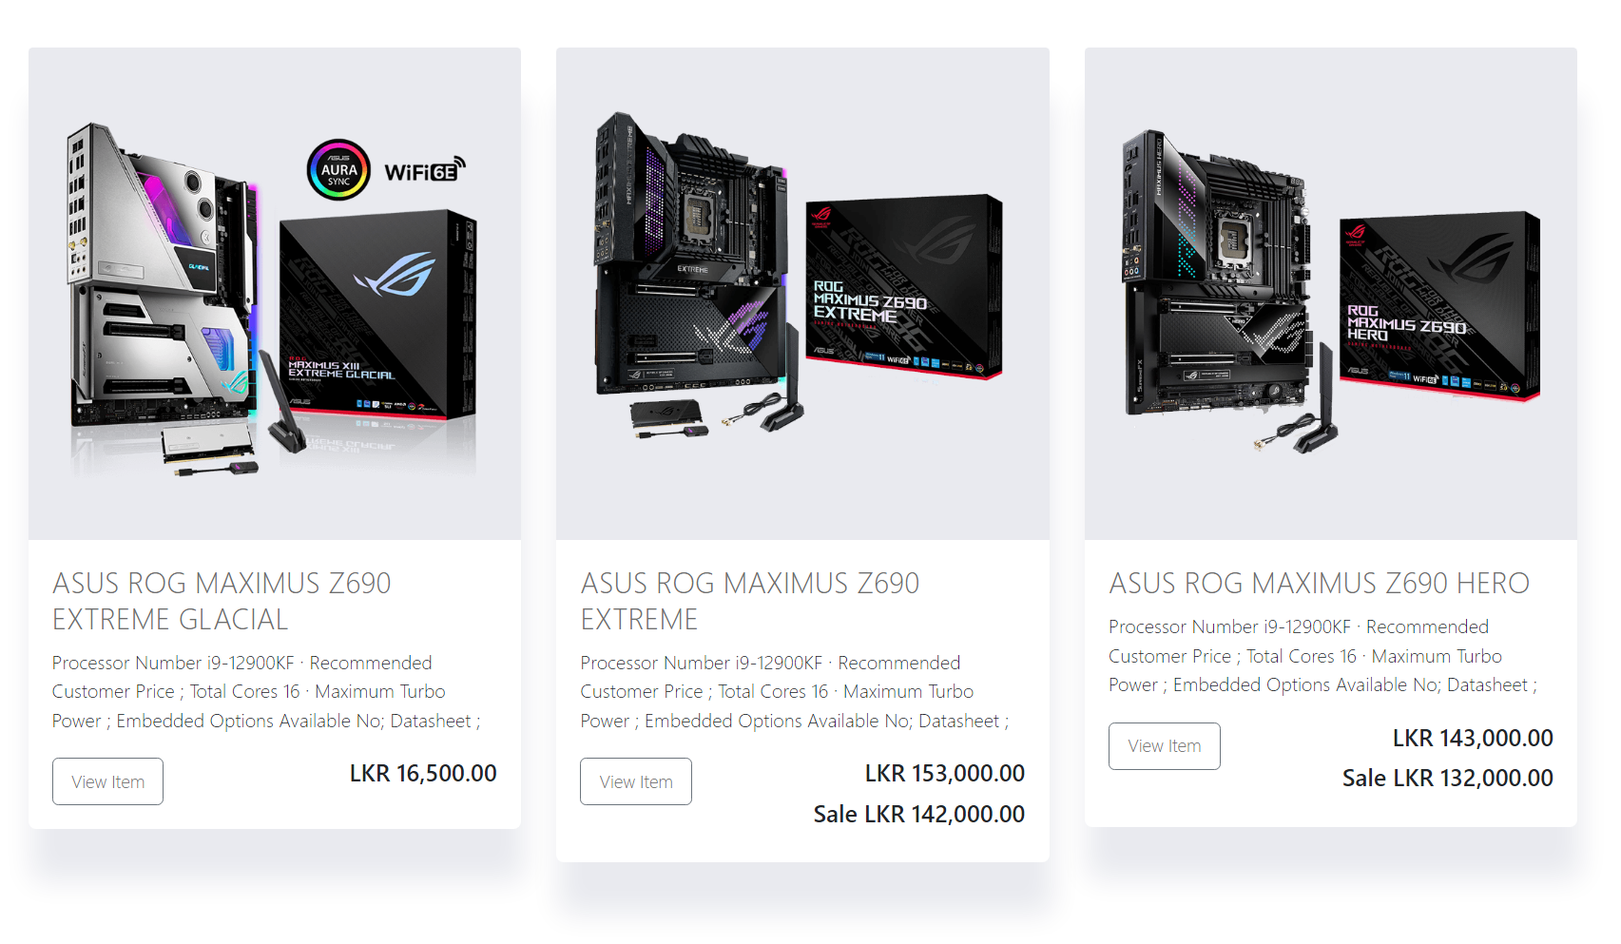

Figure C. : List Item Page

Individual item page for the selected item.

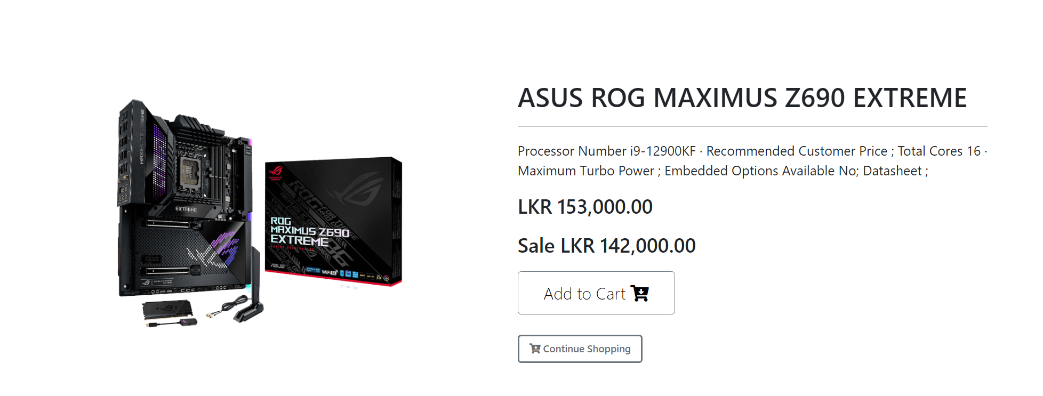

Figure C. : Item Page

Customers can check out the order through the cart page.

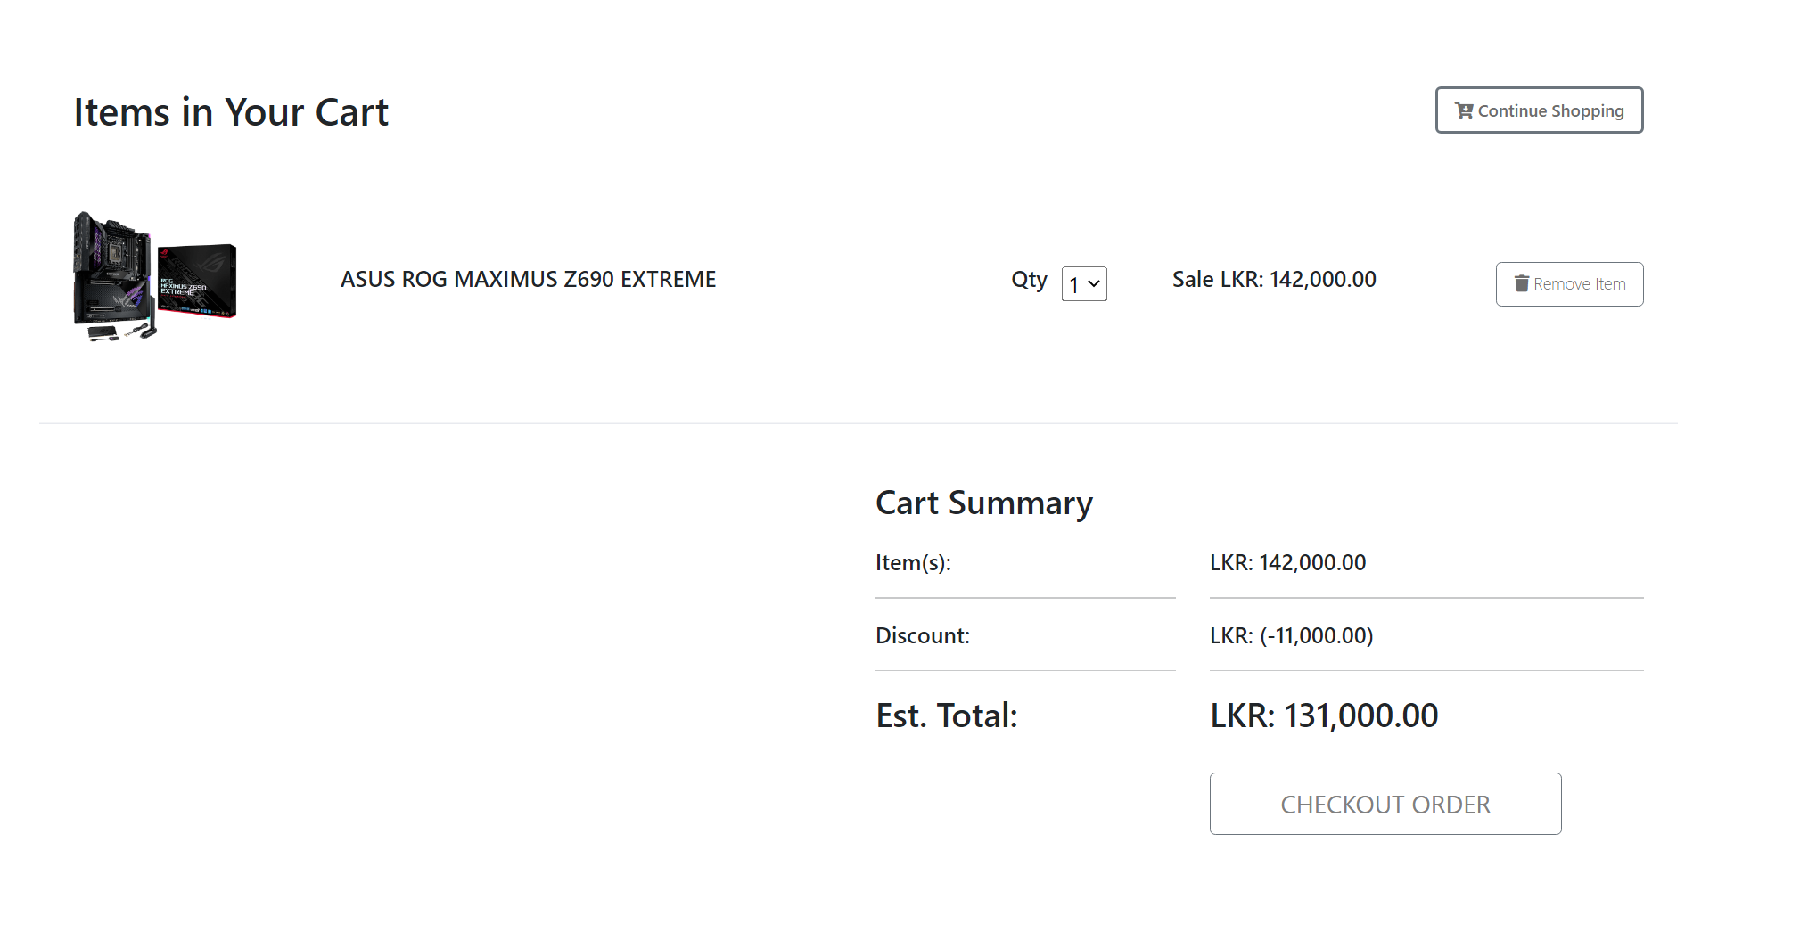

Figure C. : Cart Page

Checkout page to enter customer billing and delivery details.



Figure C. : Checkout Page

Complete order by generating the invoice.

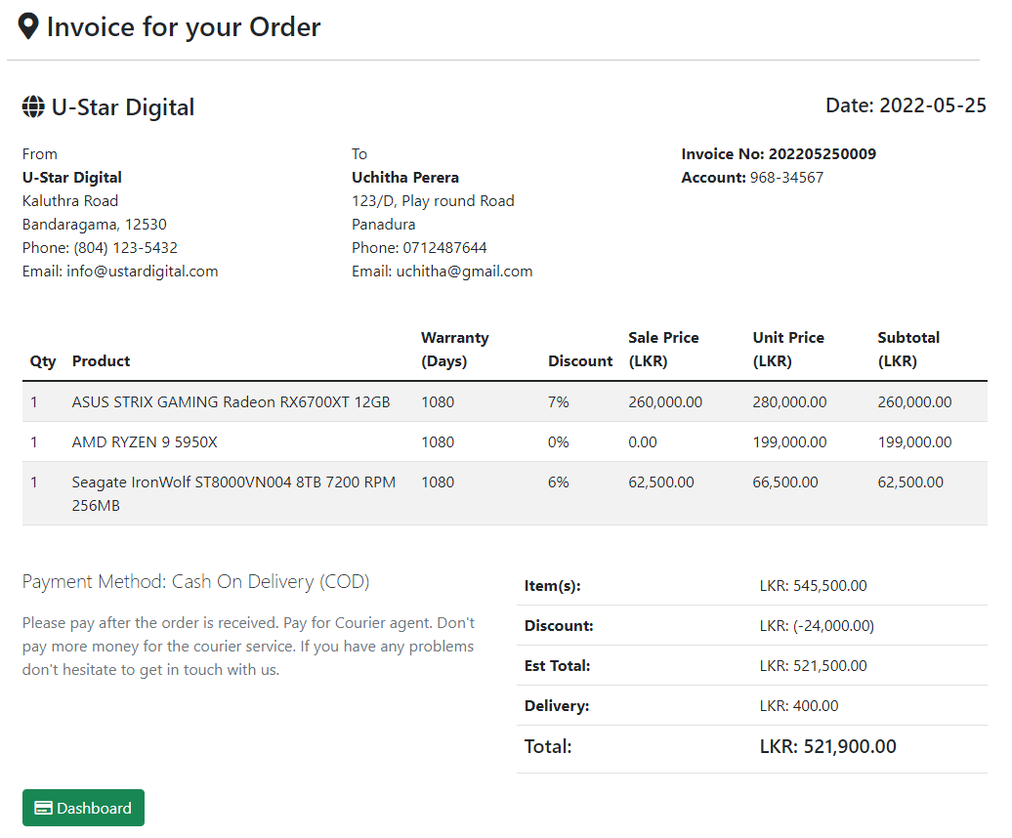

Figure C. : Invoice Page

**User Manual Part 2**

**User: Inventory Manager**

The inventory manager in U-Star Digital can handle the inventory items. To access the inventory manager dashboard, the inventory manager must use the <http://localhost/ustar/system/inventory/> URL.

After successful login, the inventory manager needs to add a category of the appropriate item.

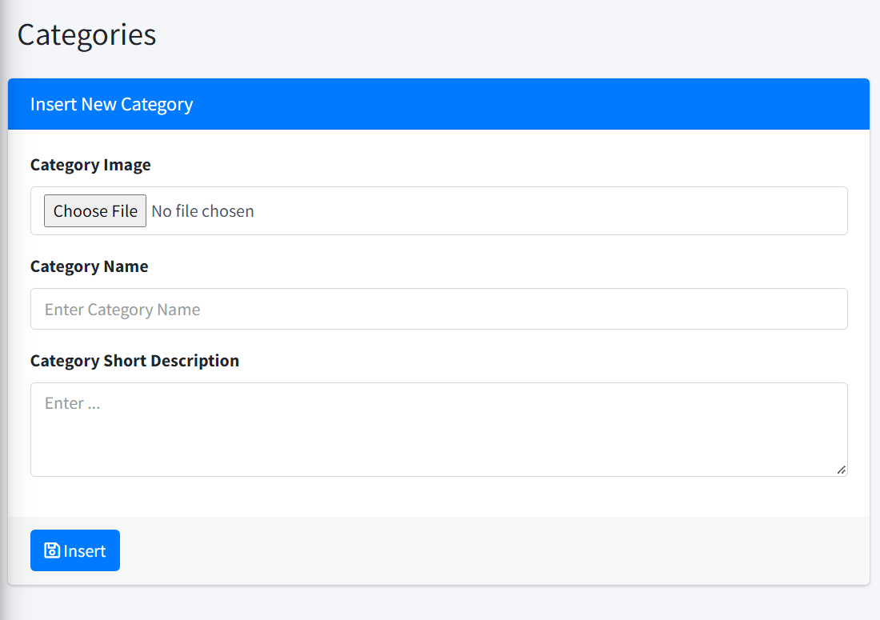

Figure C. : *Add Category Form*

Next need to add the appropriate brand of the item.

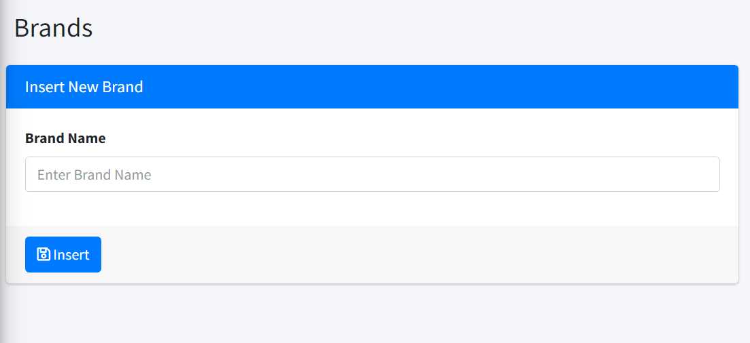

Figure C. : Add Brand Form

Next need to add the appropriate Model of the item.

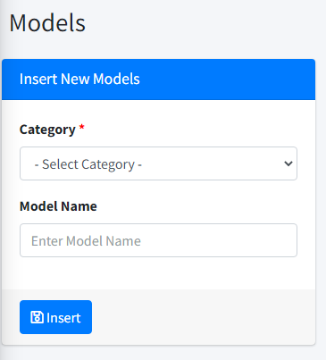

Figure C. : Add Models Form

Next need to add appropriate item details of the item.



Figure C. : Add Items Form

**User Manual Part 3**

**User: Administrator**

The Administrator in the U-Star Digital can handle the users, user modules, and user roles. To access the Administrator dashboard, the Administrator must use the <http://localhost/ustar/system/> URL. After successfully login administrator can add users to the system.

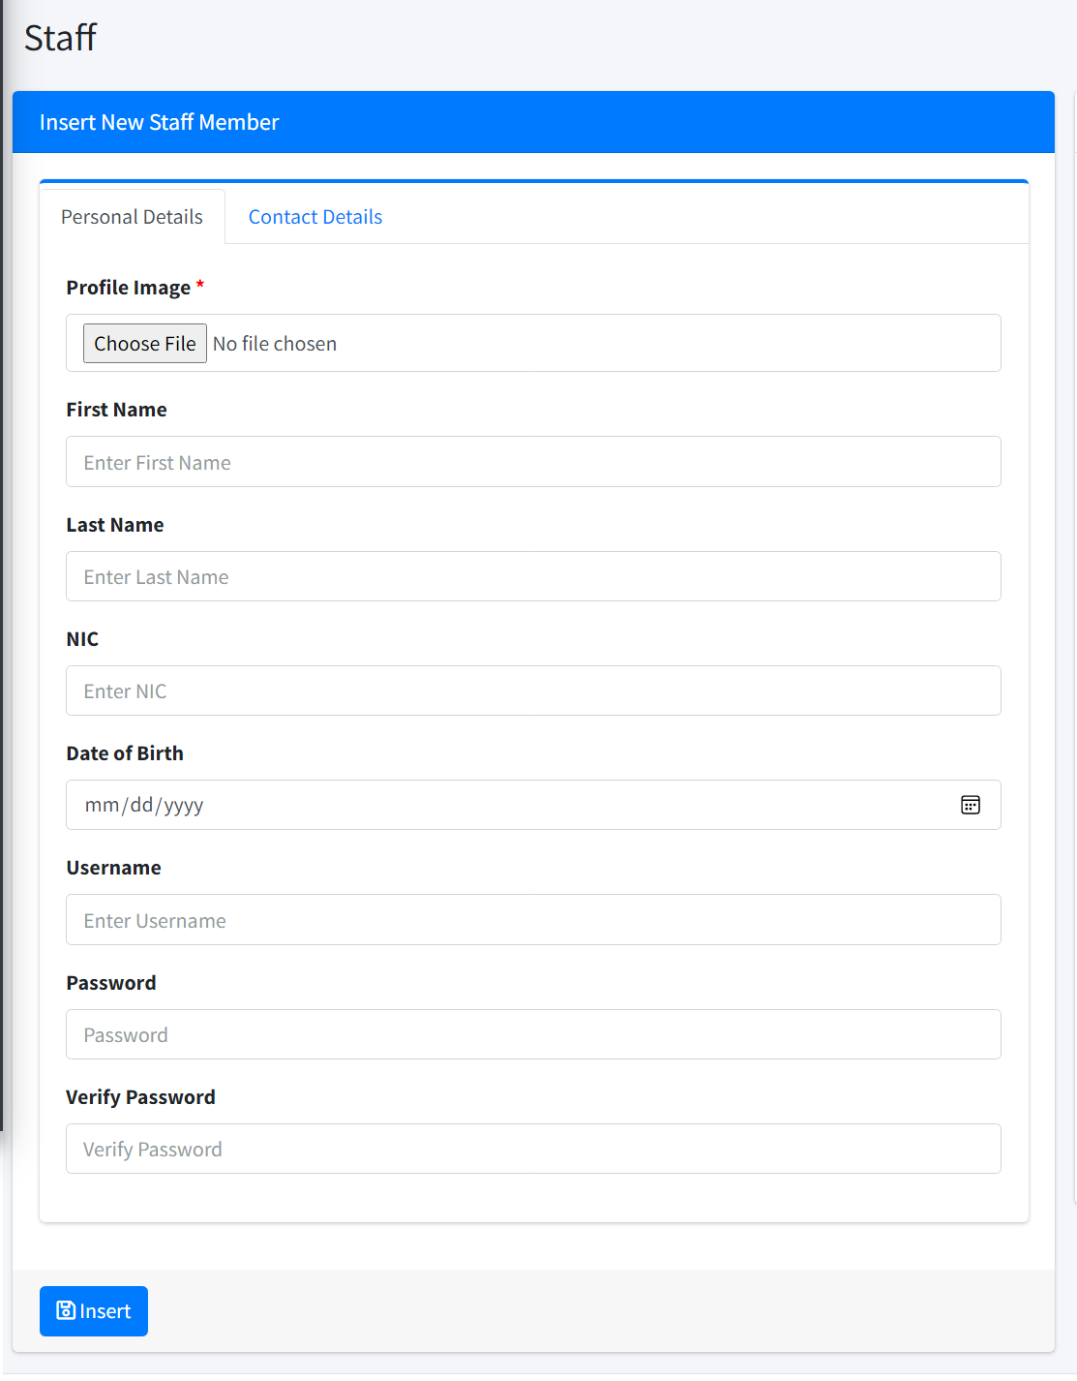

Figure C. : Add Employee

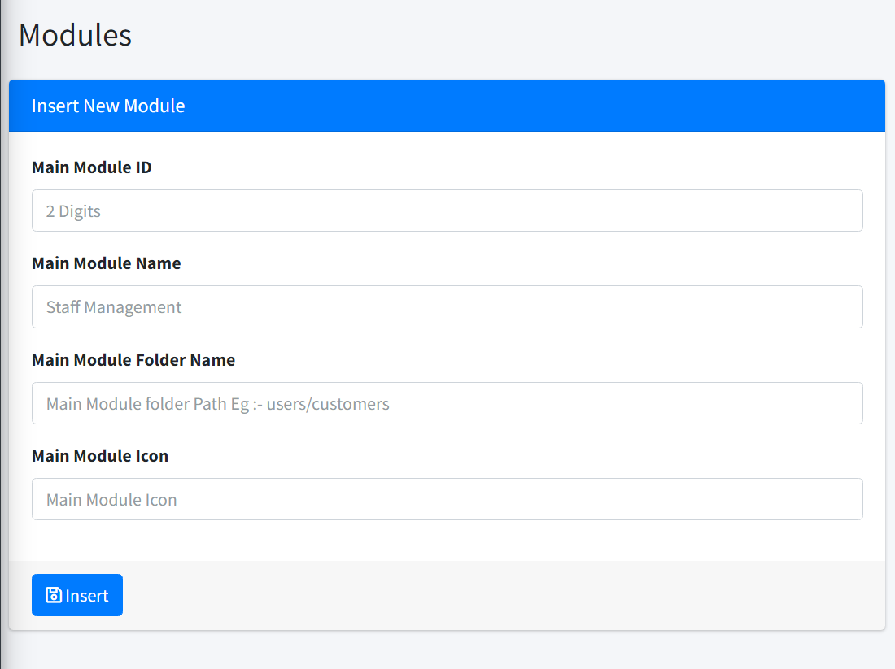

Figure C. : Add user modules

# Appendix D – Management Reports

The major reports that can be generated with the system are shown below.

* **Revenue Detail Report**

Figure D.1 shows all the revenue report that the shop manager saw between May 17th and March 25th, 2022.

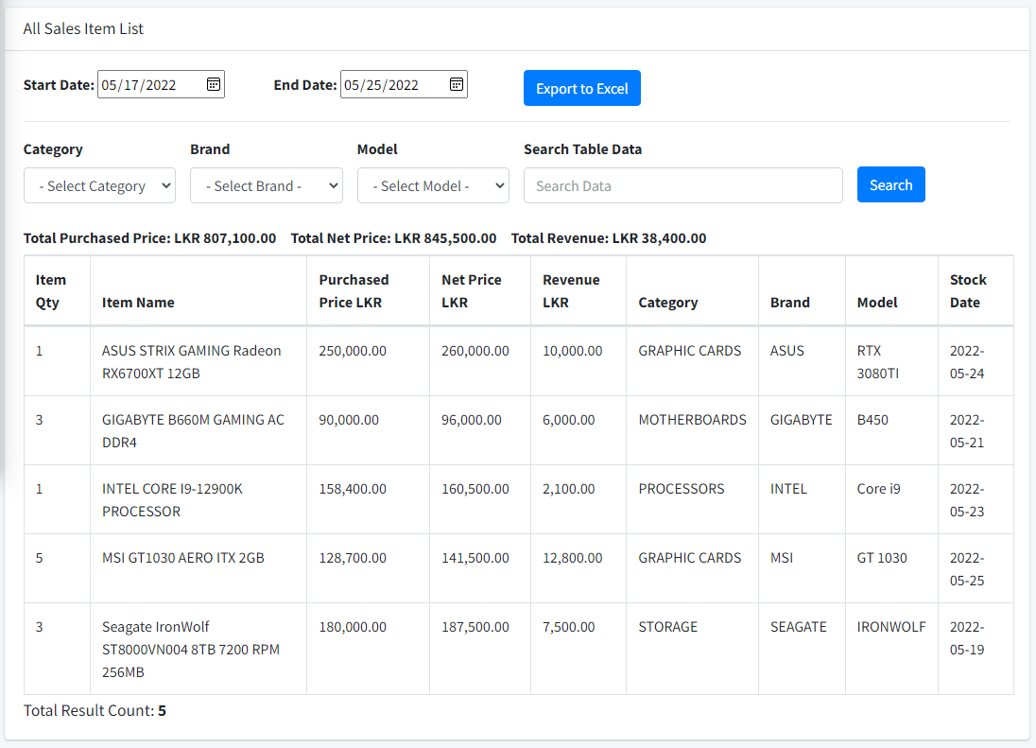

Figure D. : Report of Orders

* **Revenue Summary Report**

Figure D.2 was generated to view summary of the revenue.

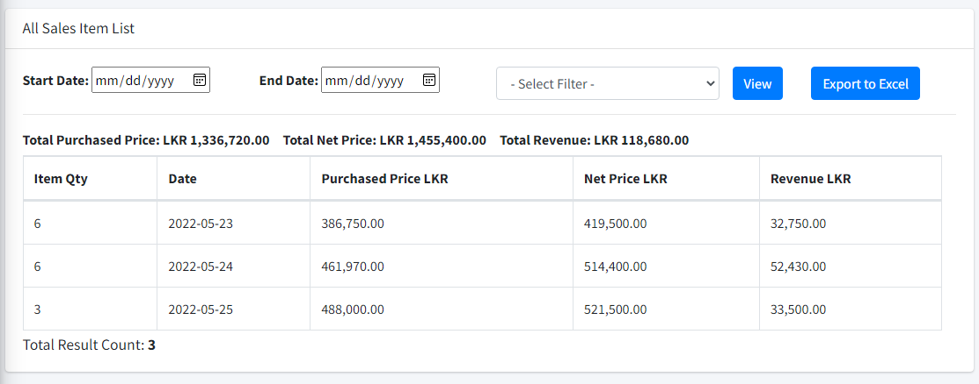

Figure D. : Report of Items

* **Delivery Report**

Figure D.3 was generated to view all delivered orders of the system.

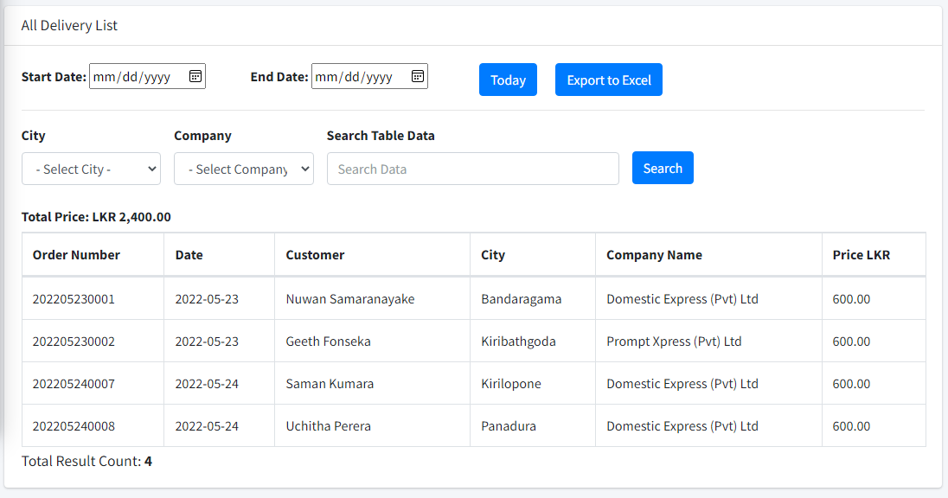

Figure D. : Report of Order Deliveries

* **Inventory Report**

Figure D.4 was generated to view all items in the system.

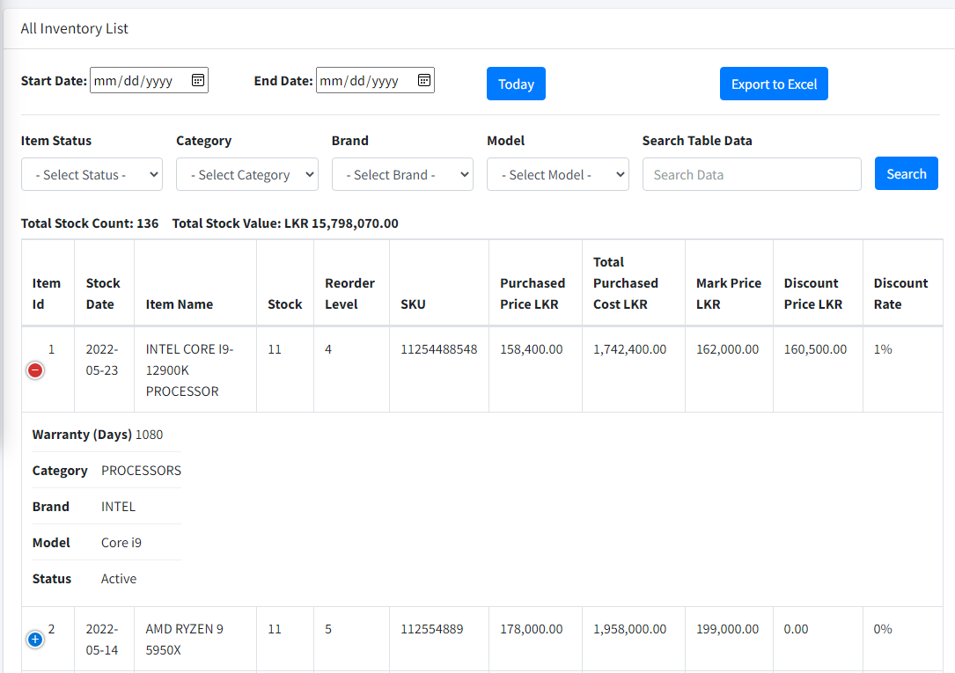

Figure D. : Report of Stock

* **Customer Report**

Figure D.5 was generated to view all customers in the system.

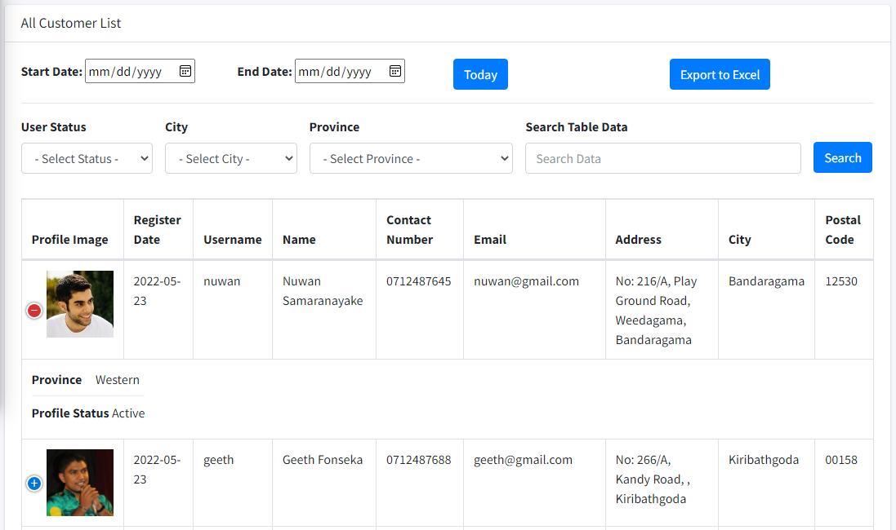

Figure D. : Report of Product Categories

# Appendix E – Test Results

**Test Result for Customer Registration**

|  |  |  |  |
| --- | --- | --- | --- |
| **Test No** | **Test Case** | **Expected Result** | **Actual Result** |
| 1 | Submit the form without filling in the mandatory fields. | Prevent submitting and show error messages |  |
| 2 | Use already exists username and email address | show error message |  |
| 3 | Enter already exists email address | show error message |  |
| 4 | Incorrect Password length insert | show error message |  |
| 6 | Invalid phone number insert | show error message |  |
| 7 | Enter the numbers in the text fields | show error message |  |
| 8 | Invalid zip inserts | show error message |  |
| 9 | Submit Correct Register Data | Navigate to the complete profile page |  |
| 10 | Submit the form with the correct data | Redirect to the login page |  |
| 11 | Without login URL browsing to the customer dashboard | Redirect to login page |  |

Table E. : Test Result for Customer Registration

**Test Result for Customer Login**

|  |  |  |  |
| --- | --- | --- | --- |
| **Test No** | **Test Case** | **Expected Result** | **Actual Result** |
| 1 | Enter valid username and password | Successful login to the system |  |
| 2 | Enter username only | show error message |  |
| 3 | Enter only password | show error message |  |
| 4 | Enter invalid username and password | show error message |  |

Table E. : Test Result for Customer Login

* **Test Result for Checkout Process**

|  |  |  |  |
| --- | --- | --- | --- |
| **Test No** | **Test Case** | **Expected Result** | **Actual Result** |
| 1 | Submit the form without filling in the mandatory fields. | Prevent submitting and show error messages |  |
| 2 | Enter the numbers in the text fields | show error message |  |
| 3 | Invalid phone number insert | show error message |  |
| 4 | Invalid zip inserts | show error message |  |
| 5 | Without check the delivery check box | Show error message of delivery form |  |
| 6 | Without selecting the payment method | Show error message |  |
| 7 | Change the delivery value related to the province | Show delivery charges and calculate to total |  |
| 8 | Submit the form with the correct data | direct to the invoice page |  |
| 9 | Without login URL browsing to the checkout and invoice | Redirect to the cart page |  |

Table E. : Test Result for Checkout Process

* **User Acceptance Test Results**

Figure E.1, Figure E.2, E.3, and Figure E.4 show the results of user acceptance testing.

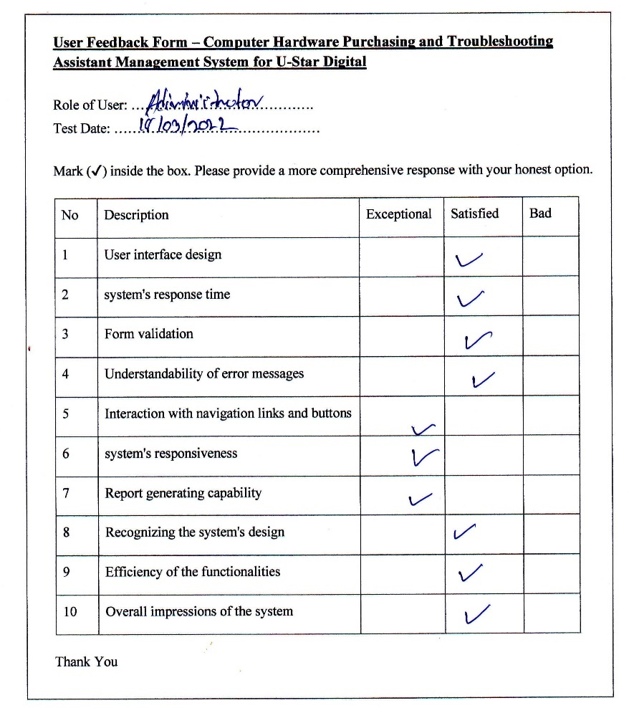

Figure E. : User Acceptance Test Result One

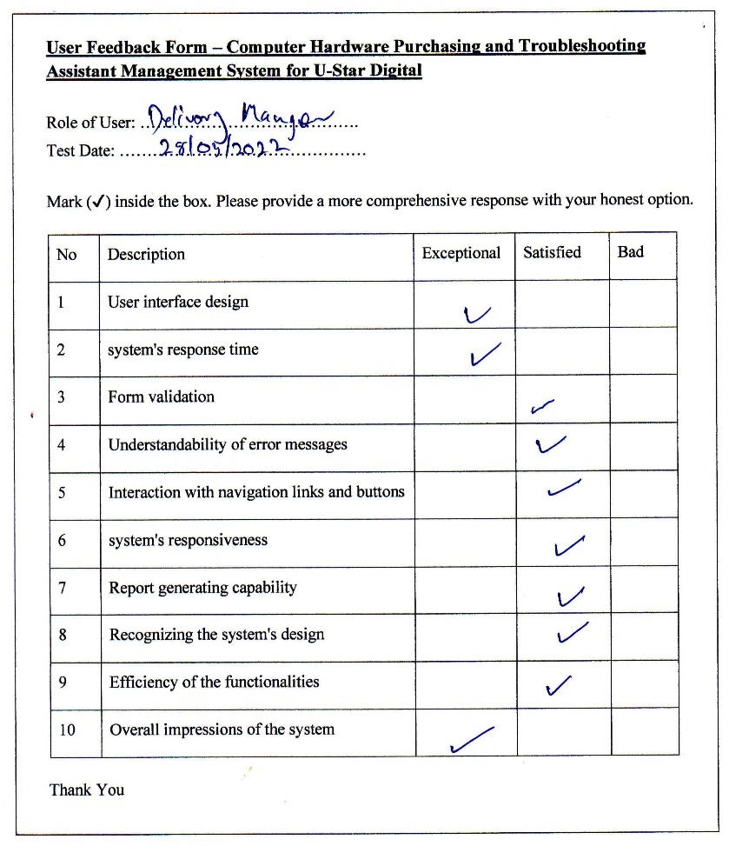

Figure E. : User Acceptance Test Result Two

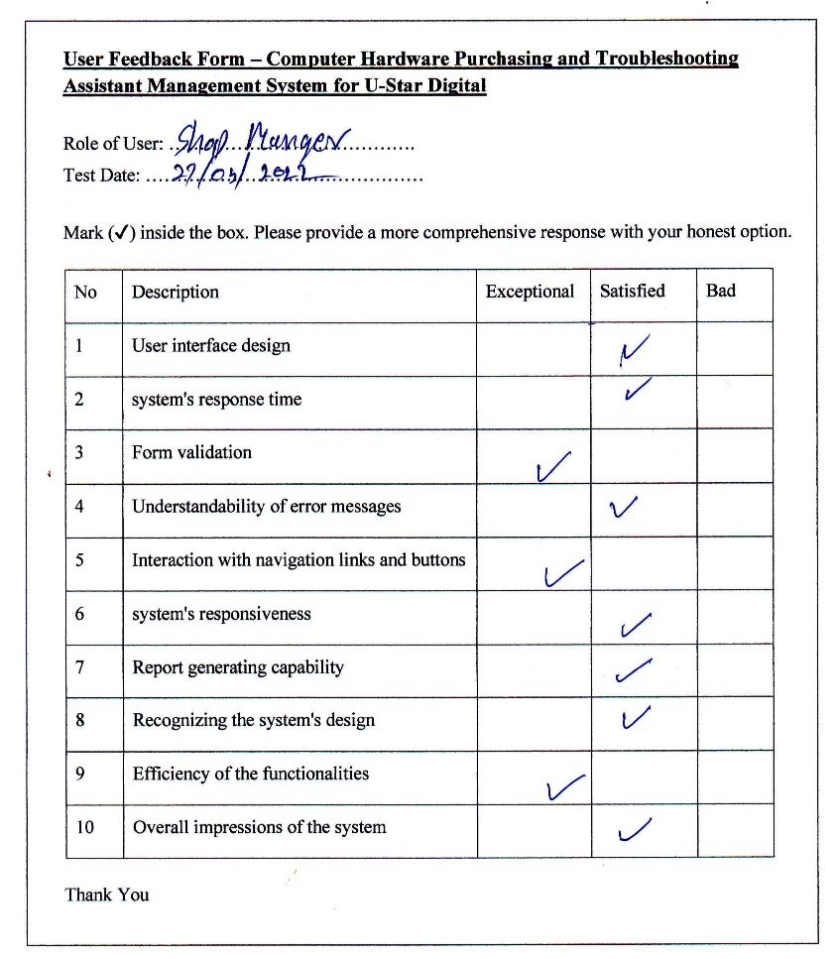

Figure E. : User Acceptance Test Result Three

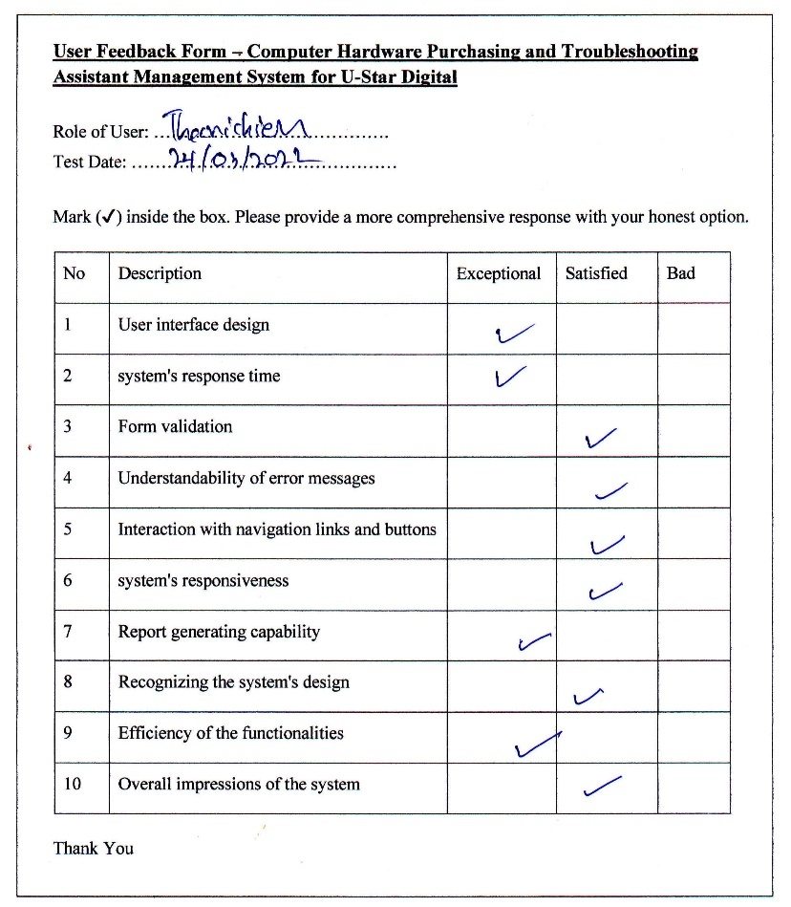

Figure E. : User Acceptance Test Result four

# Appendix F – Client Certificate



# Glossary

**AJAX** – Asynchronous JavaScript and XML is a collection of web development strategies that make use of a variety of web technologies.

**FIFO** – It is a cost flow assumption approach used in the computation of the cost of goods sold. The FIFO technique assumes that a company's oldest products have been sold first. The calculations are based on the prices paid for the oldest products.

**CSS** – Cascading Style Sheet is a style sheet language that describes how a document authored in a markup language should be presented.

**IDE** – IDE stands for Integrated Development Environment, which is a tool that allows computer programmers to develop, run, debug, and inspect their code.

**MySQL** – MySQL is an open-source relational database management system based on structured query language that is backed by Oracle.

**JavaScript** – An interpreted programming language. Use to create dynamic front-end developments.

**jQuery** – JavaScript library that is used in conjunction with HTML. It's a JavaScript library that's quick, tiny, and packed with features.

# Index

A

**AI** 57

Ajax 37

**AJAX** xii, 88

Apache iii, xii, 37, 38, 60

**application** 26, 38, 57

**assistant** 15, 57

B

**BIT** iv, xii

C

Cart 14, 20, 23, 70

**CD** xii, 61

Checkout 35, 44, 51, 52, 64, 65, 67, 71, 82, 84

computers iii, 13, 22

CSS iii, xii, 37, 39, 45, 88

customers iii, 13, 14, 23, 27, 30, 57, 63

Customers iii, 13, 18, 20, 21, 29, 57, 68, 69, 70

D

database iii, 16, 26, 27, 39, 57, 60, 61, 88

delivery iii, 13, 14, 15, 18, 51, 52, 65, 71, 83

Delivery 15, 17, 20, 23, 27, 29, 40, 68, 78

Dissertation 15

documents iii, 38, 56

Documents 17, 18

E

**ER** xii, 31

Evaluation xii, 16, 48, 52, 54, 55

F

**FIFO** xii, 88

H

hardware iii, 13, 14, 15, 16, 18, 27, 37, 57, 59, 68

Hardware i, 14, 22, 23, 26, 37, 38, 53, 56, 59

HTML iii, xii, 37, 39, 88

I

**IDE** xii, 37, 88

Interviews 17

Inventory 14, 15, 20, 23, 26, 27, 29, 30, 36, 40, 68, 72

J

JavaScript iii, xii, 37, 39, 45, 88

JQuery 37, 39

M

Microcenter 22, 23

MySQL iii, 37, 39, 60, 88

N

Newegg 23, 58

O

Observation 17, 18

order iii, iv, 13, 14, 15, 17, 18, 20, 21, 22, 24, 37, 45, 48, 64, 65, 67, 70, 72, 77

P

Payment 14, 20, 23

**PEB** xii

**PHP** iii, xii, 37, 39

**Proactive** 48

purchased iii, 13

R

**Reactive** 48

Report 15, 21, 40, 53, 77, 78, 79

Requirements 17, 20, 21, 25, 59

**RUP** xii, 24, 25, 58

S

Scrum 24, 25

**Security** 22

**SQL** xii

student 56

T

technician iii, 13, 18

Techniques 17

**Test** 48, 50, 51, 52, 53, 54, 58, 80, 81, 82, 84, 85, 86

**troubleshooting** 15, 27, 57

Troubleshooting i, 14, 15, 21, 22, 23, 26, 37, 40, 53, 56

U

**UAT** xii, 52

**UCSC** xii

**UI** xii, 34, 35

**UML** xii, 26, 66

university ii

**URL** xii, 20, 51, 52, 59, 68, 72, 75, 81, 84

Use Case 26, 27, 29, 30, 62, 64, 65

U-Star Digital iii, iv, 13, 14, 18, 37, 53, 56, 59, 68, 72, 75

V

**Validation** 42, 43, 49, 58

**Verification** 49, 58

Visual Studio Code iii, 37, 59

W

web-based system iii, 26

X

**XAMMP** xii, 60

**XP** xii, 24, 25

